**Letters**

**Mismatches in metabolic traits predict the effects of warming on phytoplankton competition**

**Short running title**: Physiological mismatches predict competition

Elvire Bestion1*, Bernardo Garcia-Carreras2*, Charlotte-Elisa Schaum1, Samraat Pawar2**, Gabriel Yvon-Durocher1**

1Environment and Sustainability Institute, University of Exeter, Penryn, Cornwall TR10 9EZ, UK

2 Department of Life Sciences, Imperial College London, Silwood Park Campus, Ascot, Berkshire, SL5 7PY, UK

[e.bestion@exeter.ac.uk](mailto:e.bestion@exeter.ac.uk), [bgarciacarreras@imperial.ac.uk](mailto:bernardo.garcia-carreras08@imperial.ac.uk), [C.L.Schaum@exeter.ac.uk](mailto:C.L.Schaum@exeter.ac.uk), [s.pawar@imperial.ac.uk](mailto:s.pawar@imperial.ac.uk), [g.yvon-durocher@exeter.ac.uk](mailto:g.yvon-durocher@exeter.ac.uk)

**\* Joint first authors**

**\*\* Corresponding authors:**

Gabriel Yvon-Durocher

Environment and Sustainability Institute, University of Exeter, Penryn, Cornwall TR10 9EZ, UK Add phone + fax Email: [g.yvon-durocher@exeter.ac.uk](mailto:g.yvon-durocher@exeter.ac.uk)

Samraat Pawar

Department of Life Sciences, Imperial College London, Silwood Park Campus, Ascot, Berkshire, SL5 7PY, UK Add phone + fax Email: [s.pawar@imperial.ac.uk](mailto:s.pawar@imperial.ac.uk)

**Statement of authorship:** GYD and SP conceived the study.EB and GYD designed the experiment, EB performed the experiment, SP and BGC wrote the theory. EB and BGC analysed the data, EB wrote the first draft and all authors contributed to writing.

**Data accessibility:** data will be available on dryad upon publication

**Keywords:** nutrients, phosphate, global changes, climate change, interspecific competition, trait-based ecology; metabolic theory of ecology

**Number of words in the abstract:**

**Number of words in the main text:**

**Number of references:**

**Number of figures, tables and text boxes:**

# Abstract

Understanding how changes in temperature affect interspecific competition is critical for predicting shifts in ecological communities as the climate warms. However, we currently lack empirically grounded theory that can predict the dynamics of interspecific competition from the effects of temperature on metabolism and resource acquisition. Here we develop a simple theoretical model that links mismatches in metabolic traits that capture the temperature dependence of resource acquisition to the outcome of pairwise interspecific competition in phytoplankton. We parameterised our model with metabolic traits derived from six species of freshwater phytoplankton and tested its ability to predict the outcome of competition in all pairwise combinations of the species in a factorial experiment, manipulating temperature (15 & 25ºC) and nutrient availability (1 & 30 μmol·L-1 ). The model correctly predicted the outcome of competition in 67% of the pairwise experiments from information on just four metabolic traits.

# Introduction

Climate change is predicted to be a major cause of species extinctions over the next century (Field *et al.* 2014), and a considerable threat to biodiversity (Bellard *et al.* 2012). Susceptibility to climate change will depend on species’ environmental tolerances (Pacifici *et al.* 2015), with those occupying narrower thermal niches expected to be more vulnerable to climate warming (Magozzi & Calosi 2015). Recent studies have highlighted that changes in species interactions may also play an important role in mediating the impacts of climate change on populations (Dunn *et al.* 2009; Bellard *et al.* 2012; Cahill *et al.* 2013; Field *et al.* 2014). Indeed the key drivers of global change (warming, CO2 and changes in nutrient availability) are known to affect various types of species interactions, including competition (Tylianakis *et al.* 2008). Understand how increases in temperatures affect species interactions is therefore crucial to predicting the ecological consequences of future climate change (Dunn *et al.* 2009; Kordas *et al.* 2011; Bellard *et al.* 2012; Dell *et al.* 2014; Reuman *et al.* 2014; Bestion & Cote 2017).

Metabolism sets the pace of life and dictates a host of life-history traits and attributes that determine fitness, including population growth rate, abundance, mortality and interspecific interactions (Brown *et al.* 2004; Savage *et al.* 2004; Dell *et al.* 2011). Species vary widely in the way in which their metabolism and associated ecological rates respond to temperature (Kingsolver 2009; Dell *et al.* 2011), and these differences in thermal response curves can greatly impact species interactions (Reuman *et al.* 2014; Dell *et al.* 2014). Mismatches in the metabolic traits that characterize species’ thermal response curves can arise via differences in magnitude (the elevation of the thermal performance curve), sensitivity (relative rate of increase in performance with temperature), and/or thermal optima (the temperature at which the performance is maximised) (Kordas *et al.* 2011; Dell *et al.* 2014; Pawar *et al.* 2015). Recent theory suggests that mismatches in the metabolic traits important for shaping interactions between mobile prey and predators can play a key role in determining the effects of temperature on consumer-resource dynamics (Dell *et al.* 2014; Gilbert *et al.* 2014; Pawar *et al.* 2015). Despite major advances in the ecological theory linking the effects of temperature to metabolism and species interactions (O’Connor *et al.* 2011; Dell *et al.* 2014; Gilbert *et al.* 2014; Amarasekare 2015; Uszko *et al.* 2017), there have been very few empirical tests, and to our knowledge, no large scale experimental study has confronted recent theoretical developments to assess whether mismatches metabolic traits can predict how interspecific competition responds to warming.

In aquatic ecosystems, temperature and nutrients are the main drivers of phytoplankton productivity (Litchman *et al.* 2010). Phytoplankton exhibit substantial interspecific variation in their responses to temperature and nutrient availability (Eppley & Thomas 1969; Tilman 1981; Aksnes & Egge 1991; Boyd *et al.* 2013; Thomas *et al.* 2016, 2017). This interspecific variation in metabolic and nutrient acquisition traits are widely recognised as being important drivers of competition (Tilman 1981), community assembly (Bulgakov & Levich 1999; Grover & Chrzanowski 2006; Litchman *et al.* 2010) and ultimately the productivity of phytoplankton communities (Behrenfeld *et al.* 2005). However, we currently lack experimental tests of theory that predict the dynamics of competition from mismatches in metabolic traits, which are essential components of models that forecast how the structure and functioning of phytoplankton communities respond to climate change (Follows *et al.* 2007).

Here we address this fundamental knowledge gap by deriving a model to predict how changes in nutrients and temperature affect the outcome of interspecific competition from mismatches in metabolic traits in phytoplankton. We parameterise our model with metabolic traits derived from six species of freshwater phytoplankton characterized over gradients in temperature and test the model’s ability to predict the outcome of competition in all possible pairwise combinations of the six species in a factorial experiment, manipulating temperature and nutrient availability.

# Theory

We model the scenario where two species colonise a novel environment at low densities. The simplest model of two species competing for a single limiting non-renewable resource undergoing exponential growth can be described by

(1)

(2)

where is the phytoplankton cell density (cells·mL-1), is the realised exponential growth rate (d-1) of thespecies (subscripts and ), and is time (days). The growth rate of species can in turn be modelled using the Monod equation (Monod 1949):

(3)

with being the maximum growth rate in nutrient saturated conditions (d-1), is the half-saturation constant (μmol·L-1) which is a measure of performance at low nutrient concentrations, and is the nutrient (phosphate) concentration (μmol·L-1). The temperature dependence of is expected to follow a left-skewed unimodal function of temperature, where rates increase exponentially to an optimum followed by a steeper exponential decline (Angilletta 2009). Within the ‘operational temperature range’ (OTR), the temperature range most likely to be encountered by the population (Fig 1), increases exponentially with temperature (Martin & Huey 2008; Angilletta 2009; Dell *et al.* 2011; Pawar *et al.* 2016). We assume that the temperature dependence within the OTR of both and follow the Boltzmann-Arrhenius equation (Aksnes & Egge 1991; Reuman *et al.* 2014):

(4)

(5)

where and are the values of and at a reference temperature (in K), and are the activation energies (eV) that set the relative rate of change in and with temperature, is the Boltzmann constant (eV·K-1), and is the temperature (K). The parameters of equations 4 and 5 (, , , ) can be considered as metabolic traits that characterise how resource acquisition and allocation to growth respond to temperature. We hypothesize that these metabolic traits play a central role in shaping the effects of warming competitive interactions among phytoplankton (Schaum *et al.* 2017).

Assuming equal starting densities (), we can define the competitive advantage, , of species relative to species by taking the log-ratio of their abundances at time :

(6)

(see Section S1). Thus equation 6 allows us to define competitive advantage as a function of mismatches in the metabolic traits (, , , and ) that define the temperature dependence of and for the two species. When there are no mismatches (the parameters , , , and are same in both species), and both species are expected to be equally abundant at any time point . When there are mismatches, , and the sign of indicates which species has a fitness advantage: for , species is expected to outnumber species at time , while the opposite is true for . While we cannot be sure that at time we observe the final competitive outcome between the two species, for simplicity we henceforth refer to the state of a competition (the fitness advantage) at time as the “competitive advantage”, and refer to the species with greater population size as the “winner” of the competition.

We can assess the relative importance of the metabolic traits characterising nutrient limited and resource saturated growth for predicting competitive advantage by comparing the full mismatch model for (eq. 6 above) to a simplified version that assumes nutrient saturation:

(7)

In this case, species will grow faster than species *b* if , and therefore if

(8)

The trade-off between normalisation constants (, ) and activation energies (, ) here is explicit. At , the winner is entirely determined by the ratio in the normalisation constants (the right hand side of the inequality becomes zero). However, as increases or decreases from , the relative importance of the activation energies increases, to the point that at a sufficiently large , the winner of the competition is entirely determined by whichever species has the greater activation energy (see Figure S1A in supplementary information for an example). For narrower temperature ranges, such as those discussed in this study, the winner is determined by differences in both normalisation constants and activation energies.

The sign of and can change with temperature — a “reversal” in the fitness advantage which indicates that one species can outcompete the other only within a specific temperature range (see Section S1 and an example in Figure 3).

Our model makes the following key predictions: (i) differences in individual species’ metabolic traits can predict competitive advantage between pairs of species at a given environmental temperature; (ii) will approximate in predictive power at higher nutrient concentrations, but will better predict competitive advantage at lower nutrient concentrations; and (iii) The competitive advantage will reverse with warming if the species with lower performance at low temperature (*B*0) has a sufficiently higher thermal sensitivity (.

# Methods

## Study design

We used an experimental approach to test the model’s ability to predict competition in six species of freshwater phytoplankton (Figure S2A). We first determined the temperature dependence of and , for each species independently, which were used to parameterise the model, allowing us to generate predictions on the competitive advantage for each species pair as a function of temperature and nutrient concentration. We then competed the six species in all pairwise combinations at two temperatures and two nutrient levels to test the ability of the model to predict the outcome of interspecific competition.

## Species and culture conditions

The experiment was conducted with six species of naturally co-occurring freshwater green algae, *Ankistrodesmus nannoselene, Chlamydomonas moewusii, Chlorella sorokiniana, Monoraphidium minutum, Scenedesmus obliquus* and *Selenastrum capricornutum* (Fritschie *et al.* 2014). We chose these 6 species because (i) they have similar cell sizes and (ii) can be cultured on the same media (standard COMBO culture medium without animal trace elements (Kilham *et al.* 1998)). Strains of each species were ordered in October 2015 from the Culture Collection of Algae and Protozoa (Table S2A), and grown on COMBO medium in semi-continuous culture at 15°C on a 12:12 light-dark cycle with a light intensity of 90 µmol·m-2·s-1.

## Species metabolic traits

We measured growth rates of each species across gradients in temperature and phosphate concentration. Each of the 6 species was grown in a factorial experiment at 5 temperatures and 13 phosphate concentrations, with 3 replicates per combination, for a total of 1170 cultures (Fig. S2A). We created 13 solutions of COMBO medium with different phosphate concentrations ranging from 0.01 to 50 µmol·L-1 of phosphate (Table S2B), a range relevant to phosphate concentrations commonly found in lakes (Downing *et al.* 2001). Small tissue culture flasks (Nunclon) filled with 40 mL of each solution were inoculated with each species in monoculture with 100 cells·mL-1, ensuring that the increase in phosphate concentration due to the inoculum volume (10 µL) was minimal (0.01 µmol·L-1 of phosphate). Samples were then grown at 15, 20, 25, 30, and 35°C and 90 µmol·m-2·s-1on a 12:12 light-dark cycle. Samples were shaken and their position rotated within the incubators daily. Every two days, a 200 µL sample was taken and 10 µL of 1% sorbitol solution was added as a cryoprotectant. After one hour of incubation in the dark, samples were frozen at -80°C until further analysis. Cell density in each sample was determined by flow cytometry (BD Accuri C6) on fast flux settings (66 µL·min-1), counting 10 µL per sample. The experiment was run for one month. During the experiment, some samples failed to grow properly and were therefore removed from the subsequent analyses.

## Species competition

To investigate the joint effects of temperature and phosphate availability on competition, we competed all species in all pairwise combinations (15 pairs) at two temperatures (15 and 25°C; low temperature and a temperature close to the optimum for most species, Fig. 1) and two phosphate concentrations (saturating [30 µmol·L-1] and limiting [1 µmol·L-1] concentrations, chosen from the Monod curves, Fig. 1), with each replicated 6 times (Fig. S2A), amounting to 360 samples. We also grew the 6 species in monoculture at the two temperature and nutrient levels to allow for the training and the testing of the discrimination algorithm used to separate cells from different species in the competition trial (see Supplementary Section S3). The competition experiments were carried out in 24 well plates filled with 2 mL of media, and inoculated with 100 cells·mL-1 of each species. The position of the species pairs were randomised within the plates. Plates were covered with AeraSeal breathable membrane, minimising evaporation and contamination but allowing gas exchange. The competition plates were incubated in the same way as described above for the monoculture growth curves. After 14 days, a 200 µL sample was taken and preserved as described above. Cell density was determined by flow cytometry on the slow flux setting (14 µL·min), counting 20 µL per sample.

## Data analyses

All statistical analyses were undertaken using R v3.3.2 (R Core Team 2014).

## *Species metabolic traits*

To characterise the effects of phosphorous availability and temperature on growth we estimated specific growth from the time-series of cell densities. Population dynamics were fitted to the Buchanan three-phase linear growth model (Buchanan *et al.* 1997) using non-linear least squares regression

(9)

where is the duration of the lag phase (days), the time when the maximum population density is reached (days), the log10 of the initial population density (log10(cells·mL-1)), the log10 of the maximum population density supported by the environment (log10(cells·mL-1)), and the specific growth rate (day-1). Fits to the Buchanan model were determined using the ‘nlsLM’ function in the ‘minpack.lm’ package (Elzhov *et al.* 2010), which uses the Levenberg-Marquardt optimisation algorithm. Parameter estimation was achieved by running 1000 different random combinations of starting parameters picked from uniform distributions and returning the parameter set with the lowest AICc score (Padfield *et al.* 2016).

The Monod equation (Eq. 3, Monod 1949), was fitted to the estimates of for each species at each temperature and for each of the three replicates using the ‘nlsLM’ function as above.

We used two approaches to describe the thermal variation in and : the Boltzmann-Arrhenius model and generalized additive models (GAMs). First, we fitted the Boltzmann-Arrhenius model on a linear scale to and on the ‘operational temperature range’, between 15 and 25°C, using a reference temperature °C (equations 4 and 5) with the ‘nlsLM’ function as above. This analysis produced normalisation constants and activation energies for both and , per species, which we then used to parameterize equations 6 and 7. Second, for each species, we fitted a GAM to and across the full temperature range over which the thermal responses are typically unimodal with the ‘mgcv’ package v1.8-17 according to equation 10.

(10)

***Competition***

The flow cytometer returned side scatter (SSC), forward scatter (FSC), and green (FL1), orange (FL2), red (FL3), and blue (FL4) fluorescence values that can be used to define a species morphology and pigment composition. We used these quantities to predict cell identity and thus quantify the relative abundances of each species in the pairwise competition experiment. After filtering the data to remove noise (Section S3), we separated the data set into 3 data sets, one for the training isolates subset, one for the testing isolates subset, and one for the competing species. The training isolates dataset was used to establish pairwise discrimination functions between pairs of species, using 3 different procedures: a linear discriminant analysis, a random forest analysis and a recursive partitioning and regression tree analysis (see Supplementary Section S3 for more details about the discrimination procedure). These different discriminant functions were then applied to the testing isolates dataset to test their accuracy of the predictions for the different discriminant methods by creating in silico competition experiments (Section S3). The linear discriminant analysis predicted cell identity of each species in the in silico pairwise experiments with 84 % accuracy and was chosen to apply to the competition dataset (Fig. S3A, Table S3A).

After determining species identity for each sample, we computed cell density and calculated the competitive advantage, , of species relative to species by taking the ln ratio of their densities (cells·mL-1) at time , and adding 1 to account for instances one species became locally extinct. We also computed a binary competitive advantage where species was competitively dominant for and species was dominant conversely.

# Results

## *Species metabolic traits*

The responses of growth rate to phosphate concentration were well fit by the Monod equation (Fig. 1a). The half-saturation constant, , and the maximum growth rate, , varied with temperature, and the temperature response of these traits differed between the six species (Tables S3A, S3B and S3C). Maximum growth rate exhibited unimodal temperature dependence in *Ankistrodesmus*, *Chlamydomonas*, and *Selenastrum* (Fig 1b, Table S3B). In *Chlorella* and *Monoraphidium*, increased with temperature but and did not reach their optima by 35°C, while in *Scenedesmus* exhibited negligible temperature dependence (Fig 1b, Table S3B). increased with temperature for *Ankistrodesmus*, *Chlamydomonas,* and *Monoraphidium*, while the response was unimodal for *Chlorella* and *Selenastrum* and there was no discernible trend for *Scenedesmus* (Fig. 1c, Table S3C). The magnitude of the relationship between and temperature and between and temperature in the operational temperature range differed between species (Fig 1b,c, Table S3A). and were also positively correlated (Pearson *r* = 0.45 [0.27,0.60], t = 4.77, df = 88, p <0.001), highlighting a trade-off between maximum growth rate and performance at low nutrient concentrations.

## *Species competition*

The competitive advantage depended on temperature, nutrient conditions and the identity of the species pair (Fig. 2). For instance, for the pair *Ankistrodesmus-Chlorella*, *Ankistrodesmus* dominated the competition at lower temperatures while *Chlorella* dominated at higher temperatures under both nutrient conditions. For the pair *Chlorella-Monoraphidium*, *Monoraphidium* won except at high nutrient concentration and high temperature. For some species pairs, the competitive advantage was the same across temperatures and nutrient concentrations. For example, *Chlamydomonas* always won against *Ankistrodesmus*, while *Monoraphidium* dominated *Selenastrum*. Reversal of competitive advantages depending on environmental conditions were most likely to happen between temperatures (in 18 out of 30 competitions; 15 pairs and two nutrient concentrations) than between nutrient concentrations (6 out of 30, Fig 2).

The predicted fitness advantage, , derived from the full model correctly predicted 67% of the experimental outcomes (Table 1). This result is significant: only 0.6% of random parameter combinations led to a higher predictive power. Results remained largely the same when considering the two nutrient concentrations separately, but competitions at the lower temperature were better predicted by the theory. The predictability of the competitive advantage was also dependent on the species involved (Table 1). Over 80% of competitive advantages were correctly predicted for *Chlorella*, while competitions involving *Selenastrum* were considerably more difficult to predict (45%, with almost half the random parameter combinations leading to a greater predictive power). This could, in part, be due to the lower power of discrimination between cells in pairs involving this species (Table S3A), as well as to the wider confidence intervals around and (Fig 1, Tables S4A, S4B and S4C). Indeed, removing competitions involving *Selenastrum* increased the overall predictive power of the model to 80%. When there were reversals of competitive advantage between temperatures, the model correctly predicted 61 % of cases (Table 2). These reversals are due to the mismatches in thermal traits between species leading to the crossing of growth rate curves between two competing species with temperature (Figure 3). Assuming nutrient saturated conditions () only marginally affected the predictive power of the model (Table 1). Contrary to expectations, including did not improve predictions at the lower nutrient concentration. Overall, the results were robust to the statistical method used to discriminate between species (Supplementary material S6).

We also tested the model’s ability to quantitatively predict the magnitude of *R*. We found a significant but weak correlation between the predicted and observed *R* (Figure S7A, Table S7A). As for the analysis based on binary outcomes the ability of the model to predict the magnitude of *R* was better when excluding pairs involving *Selenastrum* (Table S7B, Table S7C).

# Discussion

Understanding how changes in temperature and nutrients affect competitive interactions among phytoplankton is critical to predicting how environmental change will shape the structure and functioning of aquatic ecosystems. We addressed this challenge by developing, parameterizing and testing a model that predicts competition among phytoplankton from mismatches in the traits that characterize the thermal responses of maximum growth rate and performance under nutrient limitation. Our analyses demonstrate that the relative fitness of six species of freshwater phytoplankton under changing temperatures and nutrients can be predicted with information on just four metabolic traits.

In our experiments, the response of growth rate to phosphorous availability was well fit by the Monod equation. The parameters characterizing this functional response to resource availability were temperature-dependent. Over a broad range of temperatures (15 to 35ºC) both the maximum growth rate () and the half saturation constant () exhibited non-linear temperature dependence, consistent with (Eppley 1972; Senft *et al.* 1981). However, within the operational temperature range, the temperature dependence of both and could be characterized by the Boltzmann-Arrhenius equation. For both and the activation energies and normalisation constants (value of the trait at a reference temperature) differed among the six species, emphasizing the potential for mismatches in the metabolic traits of these phytoplankton species.

We used these empirically determined metabolic traits to parameterize our model to predict the effects of changes in temperature and nutrients on the relative fitness of each species in competition with each of the others in all pairwise combinations and tested the outcome against a factorial experiment, manipulating temperature and nutrient availability. Our experiment revealed that species’ relative competitive fitness changed substantially with temperature and nutrients. Comparing the model’s predictions to the experimental results demonstrated that mismatches in metabolic traits were a good predictor of the relative competitive advantage of a species in pairwise competition, with the full model correctly predicting 67% of the experimental outcomes. In contrast to expectations, assuming competitive outcomes were influenced only by nutrient saturated growth () resulted in around the same predictive power as accounting for the effects of nutrient limitation (), even in the experiments at the low nutrient concentrations (Table 1). This could be due to greater uncertainty in our estimates of the thermal response curves of . Another reason could be that the lowest concentration of phosphate used in the competition experiment, 1 μmol·L-1, was relatively high compared to the estimated half-saturation constant of most species ( : 0.10 ± 0.11, and 1.39 ± 2.78 mean ± SD , resp. at 15°C and 25°C). Notably, 1 μmol·L-1 is lower than the vast majority of phosphorus concentrations commonly found in temperate lakes (Downing *et al.* 2001), suggesting that in natural settings, knowledge of mismatches in the temperature dependence of should be sufficient to predict the effects of warming on competitive advantages except in the most extreme oligotrophic environments.

For some combinations, one species was dominant at all temperatures and nutrient concentrations. In these cases, the competitively superior species often had a higher normalisation constant for maximum growth rate (i.e.) resulting in faster realized growth rate under all conditions (Fig. 3). There were also frequent reversals of competitive advantage, particularly with changes in temperature. Temperature-driven reversals in competitive advantage were often linked to analogous reversals in the fitness advantage predicted by the model, where the superior competitor in the warm environment typically had a higher activation energy for maximum growth rate (, Fig. 3). Overall, the full model correctly predicted the temperature and nutrient driven reversals in competitive advantage in 61% of cases. These results demonstrate that metabolic traits play a central role in shaping competitive interactions among phytoplankton and highlight that particular combinations of traits consistently predict competitive advantage under warming – e.g. high and . Our findings also suggest that a greater understanding of the variance in metabolic traits at local to global scales is urgently needed if we are to predict how the structure and functioning of planktonic ecosystems will be affected by climate change (Litchman & Klausmeier 2008; Litchman *et al.* 2010).

Despite the good agreement between our model and the median experimental outcomes, the results should be interpreted with some caution because the measured fitness coefficients were often very variable among the six replicates in each pairwise interaction (Figure S3B). Such variability might reflect natural intra-population variability in traits, which is not captured by the model that is parameterized by the average trait values for each species. It could also be driven by experimental precision in quantifying the competitive outcomes in small volume, high-throughput batch-culture experiments. Future work will be needed to verify these results in smaller scale experiments using high precision chemostat methods. Nevertheless, in spite of this variability, the median competitive advantage for species pairs were highly predictable (80%), particularly when excluding interactions involving *Selenastrum*, suggesting that the model’s assumptions are nonetheless appropriate for most species. The poor predictability of interactions involving *Selenastrum* warrants further attention. This effect might simply reflect the fact that our ability to discriminate and quantify this species when in combination with the others using the linear discriminant algorithm was poor (Table S3Aa). It may also suggest other factors not accounted for in the model, such as direct interspecific interference (e.g., through the production of toxins) were important. Indeed, total polyculture yields involving *Selenastrum* were substantially lower than expectations based on the weighted average of the monoculture yields (Table S8A, (Loreau & Hector 2001)), indicating strongly negative interactions that would be consistent with interspecific interference.

Overall, our findings revealed that shifts in competitive fitness among six species of freshwater phytoplankton with changes in temperature and nutrient availability were well predicted from basic information on the metabolic traits that characterize the response of growth and resource acquisition to temperature. These results emphasize the potential for using metabolic traits to predicting how environmental change will influence the ecological dynamics of microbial communities. However, extending these findings beyond pairwise interactions to complex multi-species communities will require further work in two main areas. First, an understanding of the impact of potential higher-order interactions when scaling from pairwise responses to multi-species interaction networks where complex indirect feedbacks can result in emergent non-linear effects is urgently required (Beppler *et al.* 2017). Second, a more comprehensive understanding of metabolic trait variation at local and regional scales is needed to expand these pairwise models to a meta-community, trait-based theoretical framework.

**Acknowledgements:** We thank Saskia Johnson and Emily Budd for their help in the preliminary experiments. This work was supported by a NERC grant number XXXXXX to SP and GYD.

# References

1.  
Aksnes, D.L. & Egge, J.K. (1991). A theoretical model for nutrient uptake in phytoplankton. *Marine Ecology Progress Series*, 70, 65–72

2.  
Amarasekare, P. (2015). Effects of temperature on consumer–resource interactions. *J Anim Ecol*, 84, 665–679

3.  
Angilletta, M.J. (2009). *Thermal Adaptation: A Theoretical and Empirical Synthesis*. Oxford University Press

4.  
Behrenfeld, M.J., Boss, E., Siegel, D.A. & Shea, D.M. (2005). Carbon-based ocean productivity and phytoplankton physiology from space. *Global Biogeochem. Cycles*, 19, GB1006

5.  
Bellard, C., Bertelsmeier, C., Leadley, P., Thuiller, W. & Courchamp, F. (2012). Impacts of climate change on the future of biodiversity. *Ecology Letters*, 15, 365–377

6.  
Beppler, C., Tekin, E., White, C., Mao, Z., Miller, J.H., Damoiseaux, R., *et al.* (2017). When more is less: Emergent suppressive interactions in three-drug combinations. *BMC Microbiology*, 17, 107

7.  
Bestion, E. & Cote, J. (2017). Species Responses to Climate Change: Integrating Individual-Based Ecology Into Community and Ecosystem Studies. In: *Reference Module in Earth Systems and Environmental Sciences*. Elsevier

8.  
Boyd, P.W., Rynearson, T.A., Armstrong, E.A., Fu, F., Hayashi, K., Hu, Z., *et al.* (2013). Marine Phytoplankton Temperature versus Growth Responses from Polar to Tropical Waters – Outcome of a Scientific Community-Wide Study. *PLoS ONE*, 8, e63091

9.  
Brown, J.H., Gillooly, J.F., Allen, A.P., Savage, V.M. & West, G.B. (2004). Toward a metabolic theory of ecology. *Ecology*, 85, 1771–1789

10.  
Buchanan, R.L., Whiting, R.C. & Damert, W.C. (1997). When is simple good enough: a comparison of the Gompertz, Baranyi, and three-phase linear models for fitting bacterial growth curves. *Food Microbiology*, 14, 313–326

11.  
Bulgakov, N.G. & Levich, A.P. (1999). The nitrogen : Phosphorus ratio as a factor regulating phytoplankton community structure : Nutrient ratios. *Archiv für Hydrobiologie*, 146, 3–22

12.  
Cahill, A.E., Aiello-Lammens, M.E., Fisher-Reid, M.C., Hua, X., Karanewsky, C.J., Ryu, H.Y., *et al.* (2013). How does climate change cause extinction? *Proc. R. Soc. B*, 280, 20121890

13.  
Carter, O.G. & Lathwell, D.J. (1967). Effects of Temperature on Orthophosphate Absorption by Excised Corn Roots. *Plant Physiol.*, 42, 1407–1412

14.  
Dell, A.I., Pawar, S. & Savage, V.M. (2011). Systematic variation in the temperature dependence of physiological and ecological traits. *PNAS*, 108, 10591–10596

15.  
Dell, A.I., Pawar, S. & Savage, V.M. (2014). Temperature dependence of trophic interactions are driven by asymmetry of species responses and foraging strategy. *J Anim Ecol*, 83, 70–84

16.  
Downing, J.A., Watson, S.B. & McCauley, E. (2001). Predicting Cyanobacteria dominance in lakes. *Can. J. Fish. Aquat. Sci.*, 58, 1905–1908

17.  
Dunn, R.R., Harris, N.C., Colwell, R.K., Koh, L.P. & Sodhi, N.S. (2009). The sixth mass coextinction: are most endangered species parasites and mutualists? *Proc. R. Soc. B*, 276, 3037–3045

18.  
Elzhov, T.V., Mullen, K.M. & Bolker, B. (2010). R interface to the Levenberg-Marquardt nonlinear least-squares algorithm found in MINPACK

19.  
Eppley, R.W. (1972). Temperature and phytoplankton growth in the sea. *Fishery Bulletin*, 70, 1063–1085

20.  
Eppley, R.W. & Thomas, W.H. (1969). Comparison of Half-Saturation Constants for Growth and Nitrate Uptake of Marine Phytoplankton. *Journal of Phycology*, 5, 375–379

21.  
Field, C.B., Barros, V.R. & Intergovernmental Panel on Climate Change (Eds.). (2014). *Climate change 2014: impacts, adaptation, and vulnerability: Working Group II contribution to the fifth assessment report of the Intergovernmental Panel on Climate Change*. Cambridge University Press, New York, NY

22.  
Follows, M.J., Dutkiewicz, S., Grant, S. & Chisholm, S.W. (2007). Emergent Biogeography of Microbial Communities in a Model Ocean. *Science*, 315, 1843–1846

23.  
Fritschie, K.J., Cardinale, B.J., Alexandrou, M.A. & Oakley, T.H. (2014). Evolutionary history and the strength of species interactions: testing the phylogenetic limiting similarity hypothesis. *Ecology*, 95, 1407–1417

24.  
Gilbert, B., Tunney, T.D., McCann, K.S., DeLong, J.P., Vasseur, D.A., Savage, V., *et al.* (2014). A bioenergetic framework for the temperature dependence of trophic interactions. *Ecol Lett*, 17, 902–914

25.  
Grover, J.P. & Chrzanowski, T.H. (2006). Seasonal dynamics of phytoplankton in two warm temperate reservoirs: association of taxonomic composition with temperature. *J Plankton Res*, 28, 1–17

26.  
Kilham, S.S., Kreeger, D.A., Lynn, S.G., Goulden, C.E. & Herrera, L. (1998). COMBO: a defined freshwater culture medium for algae and zooplankton. *Hydrobiologia*, 377, 147–159

27.  
Kingsolver, J.G. (2009). The Well‐Temperatured Biologist. *The American Naturalist*, 174, 755–768

28.  
Kordas, R.L., Harley, C.D.G. & O’Connor, M.I. (2011). Community ecology in a warming world: The influence of temperature on interspecific interactions in marine systems. *Journal of Experimental Marine Biology and Ecology*, Global change in marine ecosystems, 400, 218–226

29.  
Litchman, E. & Klausmeier, C.A. (2008). Trait-Based Community Ecology of Phytoplankton. *Annual Review of Ecology, Evolution, and Systematics*, 39, 615–639

30.  
Litchman, E., Pinto, P. de T., Klausmeier, C.A., Thomas, M.K. & Yoshiyama, K. (2010). Linking traits to species diversity and community structure in phytoplankton. *Hydrobiologia*, 653, 15–28

31.  
Loreau, M. & Hector, A. (2001). Partitioning selection and complementarity in biodiversity experiments. *Nature*, 412, 72–76

32.  
Magozzi, S. & Calosi, P. (2015). Integrating metabolic performance, thermal tolerance, and plasticity enables for more accurate predictions on species vulnerability to acute and chronic effects of global warming. *Global Change Biology*, 21, 181–194

33.  
Martin, T.L. & Huey, R.B. (2008). Why “Suboptimal” Is Optimal: Jensen’s Inequality and Ectotherm Thermal Preferences. *The American Naturalist*, 171, E102–E118

34.  
Mechling, J.A. & Kilham, S.S. (1982). Temperature Effects on Silicon Limited Growth of the Lake Michigan Diatom Stephanodiscus Minutus (bacillariophyceae)1. *Journal of Phycology*, 18, 199–205

35.  
Monod, J. (1949). The growth of bacterial cultures. *Annual Reviews in Microbiology*, 3, 371–394

36.  
O’Connor, M.I., Gilbert, B. & Brown, C.J. (2011). Theoretical Predictions for How Temperature Affects the Dynamics of Interacting Herbivores and Plants. *The American Naturalist*, 178, 626–638

37.  
Pacifici, M., Foden, W.B., Visconti, P., Watson, J.E.M., Butchart, S.H.M., Kovacs, K.M., *et al.* (2015). Assessing species vulnerability to climate change. *Nature Clim. Change*, 5, 215–224

38.  
Padfield, D., Yvon-Durocher, G., Buckling, A., Jennings, S. & Yvon-Durocher, G. (2016). Rapid evolution of metabolic traits explains thermal adaptation in phytoplankton. *Ecol Lett*, 19, 133–142

39.  
Pawar, S., Dell, A.I. & Savage, V.M. (2015). Chapter 1 - From Metabolic Constraints on Individuals to the Dynamics of Ecosystems. In: *Aquatic Functional Biodiversity* (ed. Jacob, A.B.W.). Academic Press, San Diego, pp. 3–36

40.  
Pawar, S., Dell, A.I., Savage, V.M. & Knies, J.L. (2016). Real versus Artificial Variation in the Thermal Sensitivity of Biological Traits. *The American Naturalist*, 187, E41–E52

41.  
R Core Team. (2014). *R: A Language and Environment for Statistical Computing*. R Foundation for Statistical Computing, Vienna, Austria

42.  
Reuman, D.C., Holt, R.D. & Yvon-Durocher, G. (2014). A metabolic perspective on competition and body size reductions with warming. *J Anim Ecol*, 83, 59–69

43.  
Savage, V.M., Gillooly, J.F., Brown, J.H., West, G.B. & Charnov, E.L. (2004). Effects of Body Size and Temperature on Population Growth. *The American Naturalist*, 163, 429–441

44.  
Schaum, C.-E., Barton, S., Bestion, E., Buckling, A., Garcia-Carreras, B., Lopez, P., *et al.* (2017). Adaptation of phytoplankton to a decade of experimental warming linked to increased photosynthesis. *Nature Ecology & Evolution*, 1, 0094

45.  
Senft, W.H., Hunchberger, R.A. & Roberts, K.E. (1981). Temperature Dependence of Growth and Phosphorus Uptake in Two Species of Volvox (volvocales, Chlorophyta)1. *Journal of Phycology*, 17, 323–329

46.  
Sterner, R.W. & Grover, J.P. (1998). Algal growth in warm temperate reservoirs: kinetic examination of nitrogen, temperature, light, and other nutrients. *Water Research*, 32, 3539–3548

47.  
Thomas, M.K., Aranguren-Gassis, M., Kremer, C.T., Gould, M.R., Anderson, K., Klausmeier, C.A., *et al.* (2017). Temperature–nutrient interactions exacerbate sensitivity to warming in phytoplankton. *Glob Change Biol*, n/a-n/a

48.  
Thomas, M.K., Kremer, C.T. & Litchman, E. (2016). Environment and evolutionary history determine the global biogeography of phytoplankton temperature traits. *Global Ecology and Biogeography*, 25, 75–86

49.  
Tilman, D. (1977). Resource Competition between Plankton Algae: An Experimental and Theoretical Approach. *Ecology*, 58, 338–348

50.  
Tilman, D. (1981). Tests of Resource Competition Theory Using Four Species of Lake Michigan Algae. *Ecology*, 62, 802–815

51.  
Tylianakis, J.M., Didham, R.K., Bascompte, J. & Wardle, D.A. (2008). Global change and species interactions in terrestrial ecosystems. *Ecology Letters*, 11, 1351–1363

52.  
Uszko, W., Diehl, S., Englund, G. & Amarasekare, P. (2017). Effects of warming on predator–prey interactions – a resource-based approach and a theoretical synthesis. *Ecol Lett*, n/a-n/a

# Figures:

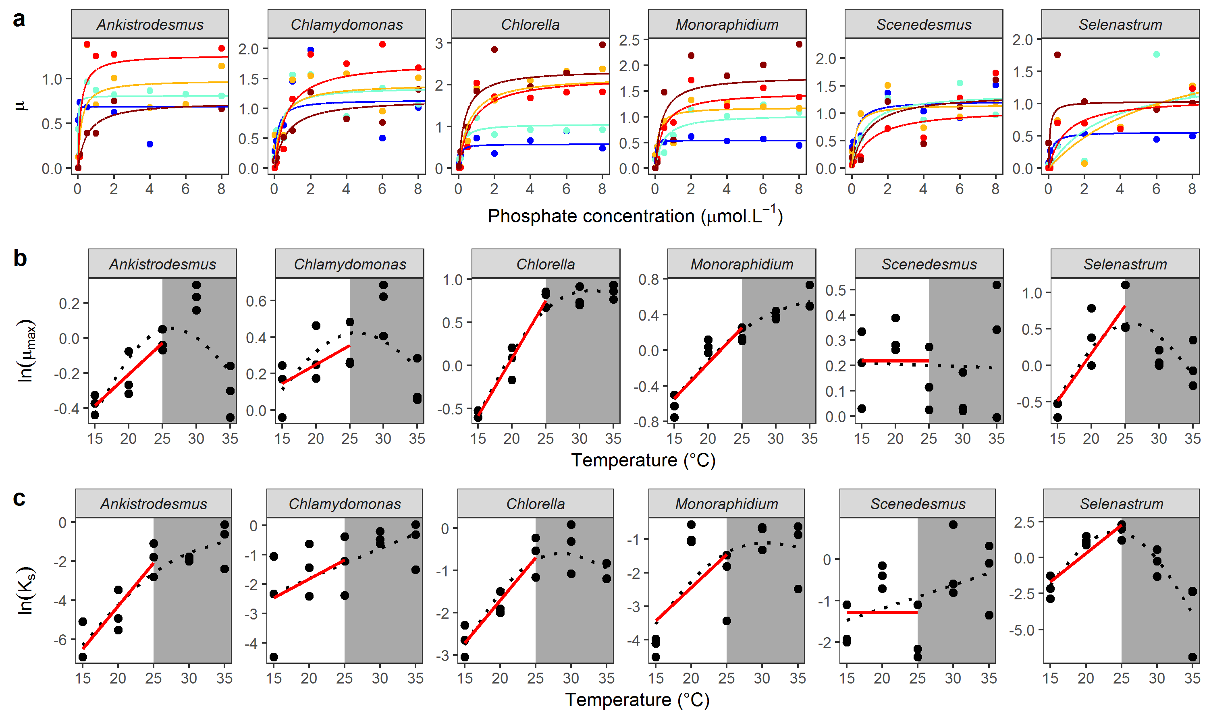

## **Fig 1**:

**(a)** Mean Monod curves for each species growth rate. Growth rate as a function of phosphate concentration in the medium (μmol·L-1) and temperature (from dark blue: 15°C to dark red: 35°C). Points represent the mean of the 3 replicates, and the Monod curve is drawn from the mean of the rate and parameters from the 3 replicates. Note that the phosphate concentration levels in the experiment go from 0.01 to 50 μmol·L-1 but the x-axis was cut at 8 μmol·L-1 for clarity. (**b)** Maximum growth rate as a function of temperature. **(c)** Half-saturation coefficient . Red lines represent the fit of the Boltzmann-Arrhenius models on temperatures inside of the operative temperature range (15 to 25°C, outside of grey rectangle). Black dotted lines represent the fit of the GAM models investigating the temperature dependence of each parameter over the whole temperature range. See Tables S4A, S4B and S4C for more details about the temperature-dependence of and .

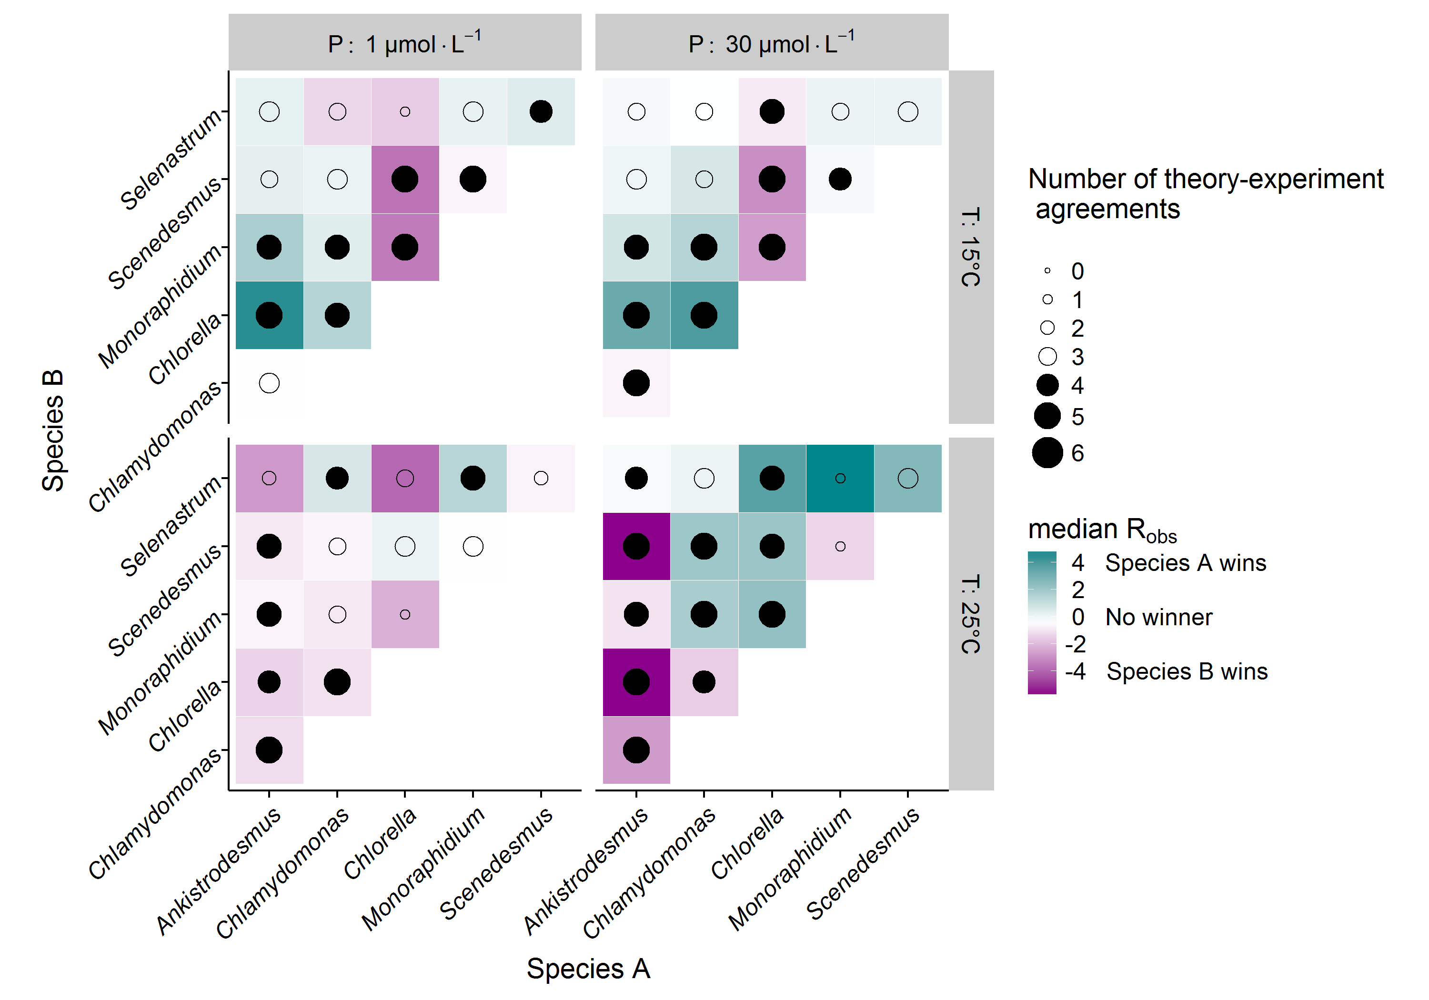

**Figure 2**: Competitive advantage for each pair of species depending on temperature and nutrient level, and agreement of the theory with the experimental outcome. Colour indicates the identity of the competitively dominant species and strength of competitive advantage (median Robs over 6 replicates, see Fig S3B for Robs by replicate). The circle shows the agreement of the model predictions with the experimental outcomes (size: number of replicates correctly predicted out of 6, see Table 1).

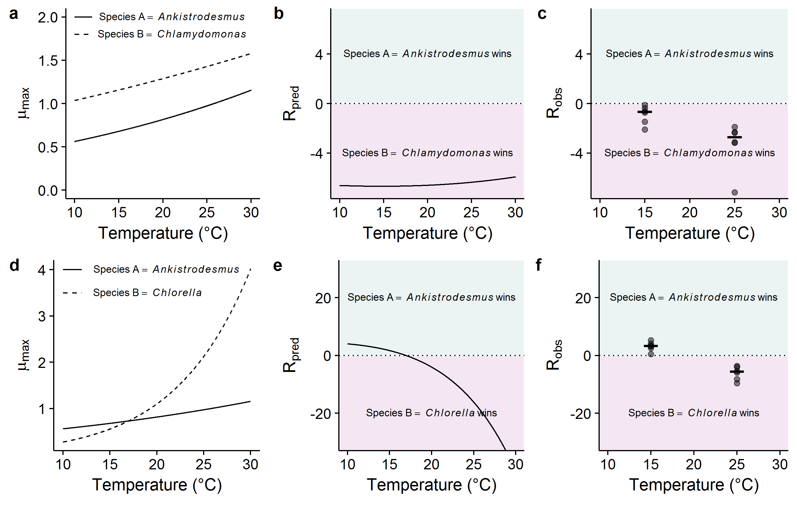

**Figure 3:** Examples of model predictions and their comparison with real data for two competitive interactions at high nutrient concentrations. (a-c) is for the competition between *Ankistrodesmus* and *Chlamydomonas*, (d-f) is for the competition between *Ankistrodesmus* and *Chlorella*. Panels (a, d) represent the temperature-dependence of derived from the Boltzmann-Arrhenius models. In the first case, is always higher for *Chlamydomonas*, while in the second case *Ankistrodesmus* has a higher at low temperatures, but a lower at high temperatures. This translates into different shapes of predicted with temperature, with a reversal of competitive advantage with temperature in the *Ankistrodesmus*-*Chlorella* competition (e) while there is no reversal in the *Ankistrodesmus-Chlamydomonas* competition (b). These theoretical predictions are in line with the experimental advantage (c, f; N = 6 replicates per temperature plus medians as segments).

# Tables

**Table 1**: Proportion of competition advantage correctly predicted by theory. Results are shown for the full dataset (including competitions at both temperatures and nutrient concentrations), by temperature, by nutrient concentration, and by species (where only competitions involving each individual species is considered in turn). The column “” uses eqn. 7 in the main text, and assumes nutrient saturated conditions, while “” corresponds to eqn. 6 in the main text, and explicitly captures nutrient limitation. “N” indicates the number of competitions in each subset. Column “ reversals” shows the proportion of competitions for which a reversal in the competitive advantage was observed between temperatures that was correctly predicted by the theory. For example, a value of 0.5 here means that the theory correctly predicted 50% of the observed reversals in the competitive advantage (given by column “N revs.”). P values indicated in parentheses were obtained by bootstrapping (see Section S5 in supplementary information). The experimental competition data uses the LDA discrimination method. Analogous results for the random forest and rpart discrimination methods are shown in Tables S6A and S6B.

|  |  |  | ***R*** |  | ***N*** | ***reversal*** |  | ***R(S) reversal*** |  | ***N reversals*** |
| --- | --- | --- | --- | --- | --- | --- | --- | --- | --- | --- |
| *Full dataset* | | | | | | | | |  |  |
|  | 0.67 | (0.006) | 0.67 | (0.005) | 342 | 0.62 | (0.000) | 0.59 | (0.002) | 521 |
| *By temperature* | | | | | | | | |  |  |
| °C | 0.73 | (0.034) | 0.70 | (0.041) | 171 | NA | ( NA) | NA | ( NA) |  |
| °C | 0.61 | (0.139) | 0.64 | (0.070) | 171 | NA | ( NA) | NA | ( NA) |  |
| *By nutrient* | | | | | | | | |  |  |
| [P] = 1 µmol·L-1 | 0.65 | (0.020) | 0.62 | (0.044) | 170 | 0.57 | (0.003) | 0.43 | (0.039) | 261 |
| [P] = 30 µmol·L-1 | 0.69 | (0.012) | 0.72 | (0.005) | 172 | 0.68 | (0.000) | 0.75 | (0.000) | 260 |
| *By species* | | | | | | | | |  |  |
| *Ankistrodesmus* | 0.78 | (0.005) | 0.75 | (0.008) | 116 | 0.67 | (0.015) | 0.59 | (0.041) | 196 |
| *Chlamydomonas* | 0.69 | (0.025) | 0.71 | (0.012) | 117 | 0.51 | (0.022) | 0.45 | (0.054) | 157 |
| *Chlorella* | 0.82 | (0.007) | 0.80 | (0.012) | 115 | 0.87 | (0.002) | 0.96 | (0.002) | 228 |
| *Monoraphidium* | 0.63 | (0.073) | 0.68 | (0.028) | 115 | 0.66 | (0.001) | 0.66 | (0.001) | 152 |
| *Scenedesmus* | 0.63 | (0.050) | 0.61 | (0.077) | 115 | 0.56 | (0.003) | 0.46 | (0.027) | 171 |
| *Selenastrum* | 0.45 | (0.771) | 0.45 | (0.751) | 106 | 0.32 | (0.083) | 0.24 | (0.253) | 138 |

**Table 2:** Number of observed and predicted reversals in competitive advantage between pair of species. Observed reversals are qualified when the median R of a pair of species across 6 replicates changes sign with temperature. They are compared to reversals predicted by the model.

|  | ***Observed revs.*** | | ***Predicted revs. ()*** | | ***Predicted revs. ()*** | |
| --- | --- | --- | --- | --- | --- | --- |
|  | *Yes* | *No* | *N* | *Prop.* | *N* | *Prop.* |
| ***Full dataset*** | | | | | | |
|  | 18 | 12 | 11 | 0.61 | 10 | 0.56 |
| ***By nutrient*** | | | | | | |
| [P]=1 µmole·L-1 | 10 | 5 | 6 | 0.60 | 4 | 0.40 |
| [P]=30 µmole·L-1 | 8 | 7 | 5 | 0.62 | 6 | 0.75 |
| ***By species*** | | | | | | |
| *Ankistrodesmus* | 7 | 3 | 5 | 0.71 | 4 | 0.57 |
| *Chlamydomonas* | 6 | 4 | 2 | 0.33 | 2 | 0.33 |
| *Chlorella* | 8 | 2 | 7 | 0.88 | 8 | 1.00 |
| *Monoraphidium* | 4 | 6 | 3 | 0.75 | 3 | 0.75 |
| *Scenedesmus* | 6 | 4 | 3 | 0.50 | 2 | 0.33 |
| *Selenastrum* | 5 | 5 | 2 | 0.40 | 1 | 0.20 |

# Supplementary Information

## S1: Theory

We aim to quantify competitive advantage or relative fitness of the competing phytoplankton species in a potentially nutrient limited environment, and how physiological mismatches affect this competitive advantage. Our starting point follows (Tilman 1977, 1981) model of two phytoplankton populations competing for a single limiting nutrient () in a chemostat-type environment:

(11)

(12)

(13)

Here, is the -th species density (cells·mL−1), is its realised growth rate (d−1), is its maximum growth rate in nutrient saturated conditions (d−1), is the half-saturation constant (μmol·L−1) (the nutrient concentration at which realised growth is ; a measure of performance at low nutrient concentrations), is the nutrient concentration (μmol·L−1), is dilution rate, and is the inflow concentration of nutrients. The constant converts units of nutrient to phytoplankton cell units (1000·μmol·cell−1); that is, it is the yield of species with respect to the limiting resource (inverse of number of phytoplankton cells produced per unit of resource).

Because the colonisation experiments do not replenish nutrients, , leaving

(14)

(15)

(16)

If we were to assume that nutrients do not deplete significantly over the course of a (14 day) experiment, the model reduces to

(17)

(18)

(19)

This simplifying assumption is reasonable in line with the experimental results (median times to carrying capacity in the growth rate experiment at 15°C, 10.5 and 14.5 days respectively at low (1 μmol·L-1 of phosphate) and high (30 μmol·L-1 of phosphate)). Nevertheless, the expected outcome at the point where we examine competitive advantage (14 days) is expected to carry the signature from the exponential growth phase, when nutrients are truly unlimited, as it integrates the changes in abundance over the time period.

Note that in this case, the two phytoplankton species have no impact on each other; we effectively model the exponential growth of the two species in isolation, and postulate that the differences in the two growth rates can predict the competitive advantage.

Experiments stipulate the same (small) number of cells at the start of a colonisation experiment, and then estimate the number of cells of each species present after a period of 14 days. The model above can be solved to provide the same information:

(20)

(21)

where is time (in days) and where the growth rate is modelled using the Monod equation, as above:

(22)

This model is the simplest we can use to model the temperature and nutrient dependent competition of two phytoplankton species, and importantly only incorporates variables measured in experiments. As a result, the model makes a number of simplifying assumptions. We assume that the exponential growth phase in a colonisation is key in determining competitive advantage, and therefore, comparing exponential growth rates between species competing for a single limiting resource is important for predicting which species might be expected to dominate. However, in the long run, and once populations reach high enough population densities, density dependence and intraspecific competition might be expected to play a role of increasing importance. At higher population densities, competing populations might also be more likely to directly interfere with each other through, for example, through the production of toxins or competition for light (inter-specific competition). Populations are also expected to experience a mortality rate, not captured in the model above. Our focus is on the initial phase of colonisation, so assume most of these factors to be of limited importance in this context. Furthermore, many of these factors are not measured in experiments, and some mechanisms (such as density dependence or intraspecific competition) can be approached a number of different ways; including these would substantially expand the study beyond its scope.

The parameters of the Monod equation, and , can be considered as ‘functional traits’ that characterise a species’ physiology. These traits have been shown to vary among species and play an important role in shaping competitive dynamics in phytoplankton communities (Tilman 1981; Bulgakov & Levich 1999). We expect maximum growth rate to be tightly coupled to metabolism, and consequently the temperature dependence of is expected to follow a left-skewed unimodal function of temperature, where rates increase exponentially to an optimum followed by a steeper exponential decline (Angilletta 2009). Within the ‘operational temperature range’ (OTR), the temperature range most likely to be encountered by the population, could be assumed to increase exponentially with temperature (Martin & Huey 2008; Pawar *et al.* 2016). The effects of temperature on are poorly understood and empirical studies have documented a wide range of temperature dependence functions (Carter & Lathwell 1967; Senft *et al.* 1981; Mechling & Kilham 1982; Aksnes & Egge 1991; Sterner & Grover 1998), although a simple theoretical model suggests is expected to increase with temperature (Aksnes & Egge 1991), and another study approximated the temperature dependence of as an exponential function (Reuman *et al.* 2014). Let the temperature dependence within the OTR of both and follow the Boltzmann-Arrhenius equation:

(23)

(24)

where and are the values of and at a reference temperature (in K), and are the activation energies (eV) that set the relative rate of increase in and with temperature, is the Boltzmann constant (eV·K-1), and is the temperature (K).

Assuming the starting densities are equivalent (), we can define the fitness advantage of species relative to species by taking the ln ratio of their abundances at time :

(25)

Note that comes about via the differences, or mismatches, in the competing species’ physiology, that is to say, via mismatches in the respective parameters that define the temperature dependence of and (, , , and ). When there are no mismatches (the equivalent parameters are the same in both species), and both species are expected to be equally abundant at any time point . When there are mismatches, , and the sign of indicates which species has a fitness advantage: for , species is expected to outnumber species at time , while the opposite is true for .

We can assess how important nutrient limitation () is for predicting the competitive advantage by comparing above to a simplified version that assumes nutrient saturation (as ):

(26)

In this case, species will grow faster than species *b* if , and therefore if

(27)

The trade-off between normalisation constants and activation energies here is explicit. At , the winner is entirely determined by the ratio in the normalisation constants (the right hand side of the inequality becomes zero). However, as increases or decreases from , the relative importance of the activation energies increases, to the point that at a sufficiently large , the winner of the competition is entirely determined by whichever species has the greater activation energy (see Figure S1A below for an example). For narrower temperature ranges, such as those discussed in this study, the winner is determined by differences in both normalisation constants and activation energies.

A reversal in the fitness advantage (a change in its sign) can be found numerically. For the nutrient saturated case, the temperature at which is given by

(28)

Here, if there is a reversal, the species that wins at the higher temperature is entirely a function of the difference in activation energies; for example, if , species is expected to outcompete species for .

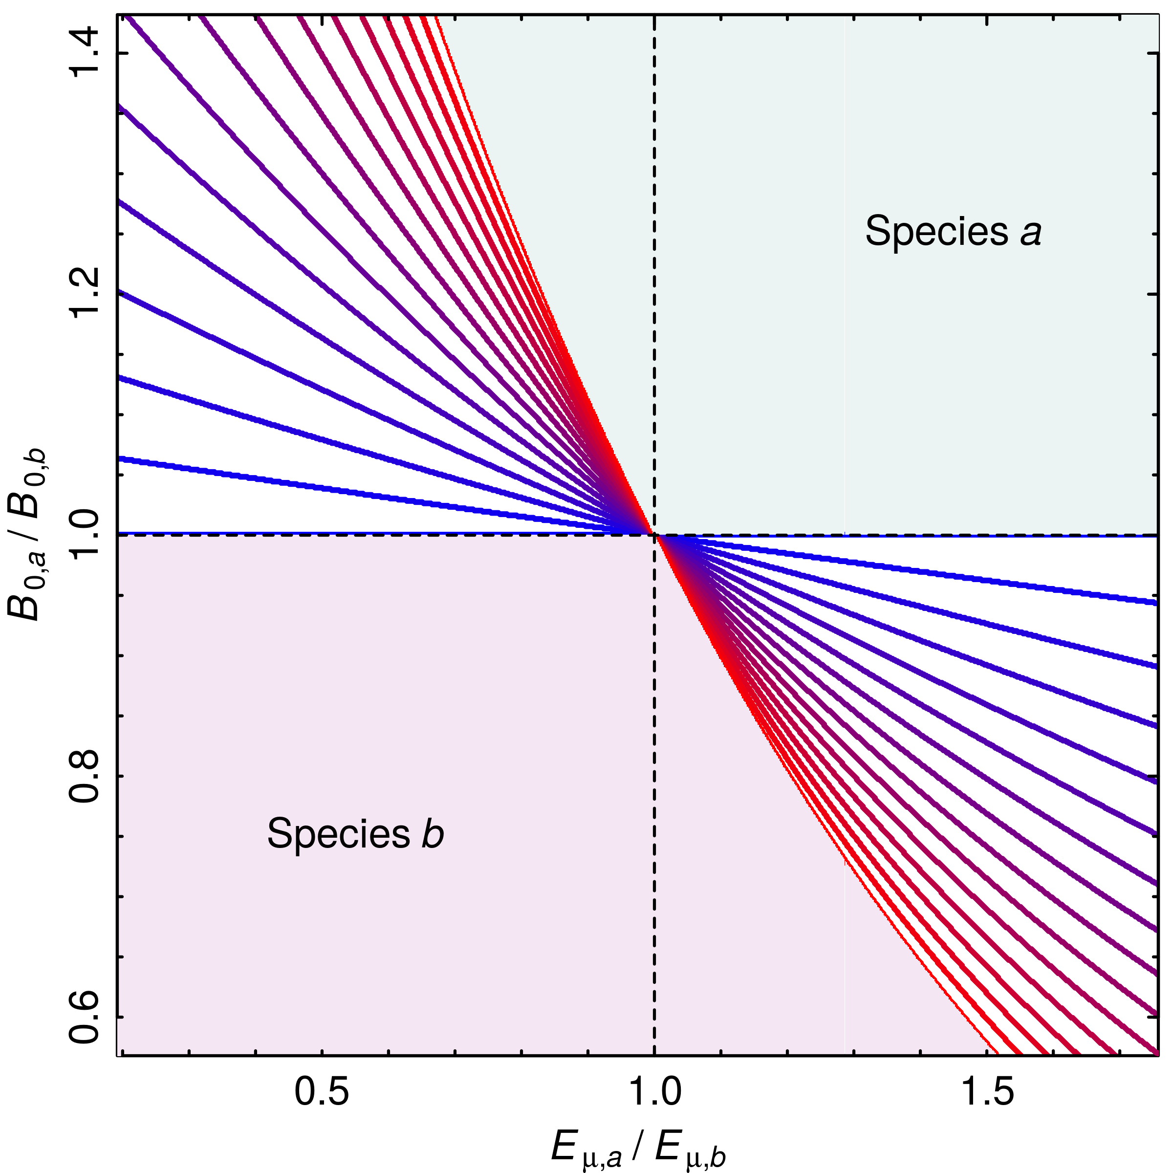

**Figure S1A:** Contour lines illustrating the competitive advantage for a range of parameter combinations, assuming nutrient saturation (). The colour of the lines correspond to different temperatures, ranging from 15°C for the blue line, to 30°C for the red line. For example, for = 1 and = 0.8, species *b* grows faster than species *a*, but for = 0.5 and = 1.2, which species grows faster depends on the temperature. Here, , , and °C. Therefore, at at °C, which species wins is determined by (the blue line is horizontal and insensitive to the ratio in activation energies), while as temperatures move further away from , the ratio of activation energies becomes increasingly important in determining the competitive advantage. As temperature increases beyond the range shown here, the lines become increasingly vertical, and as a result, insensitive to the ratio in normalisation constants.

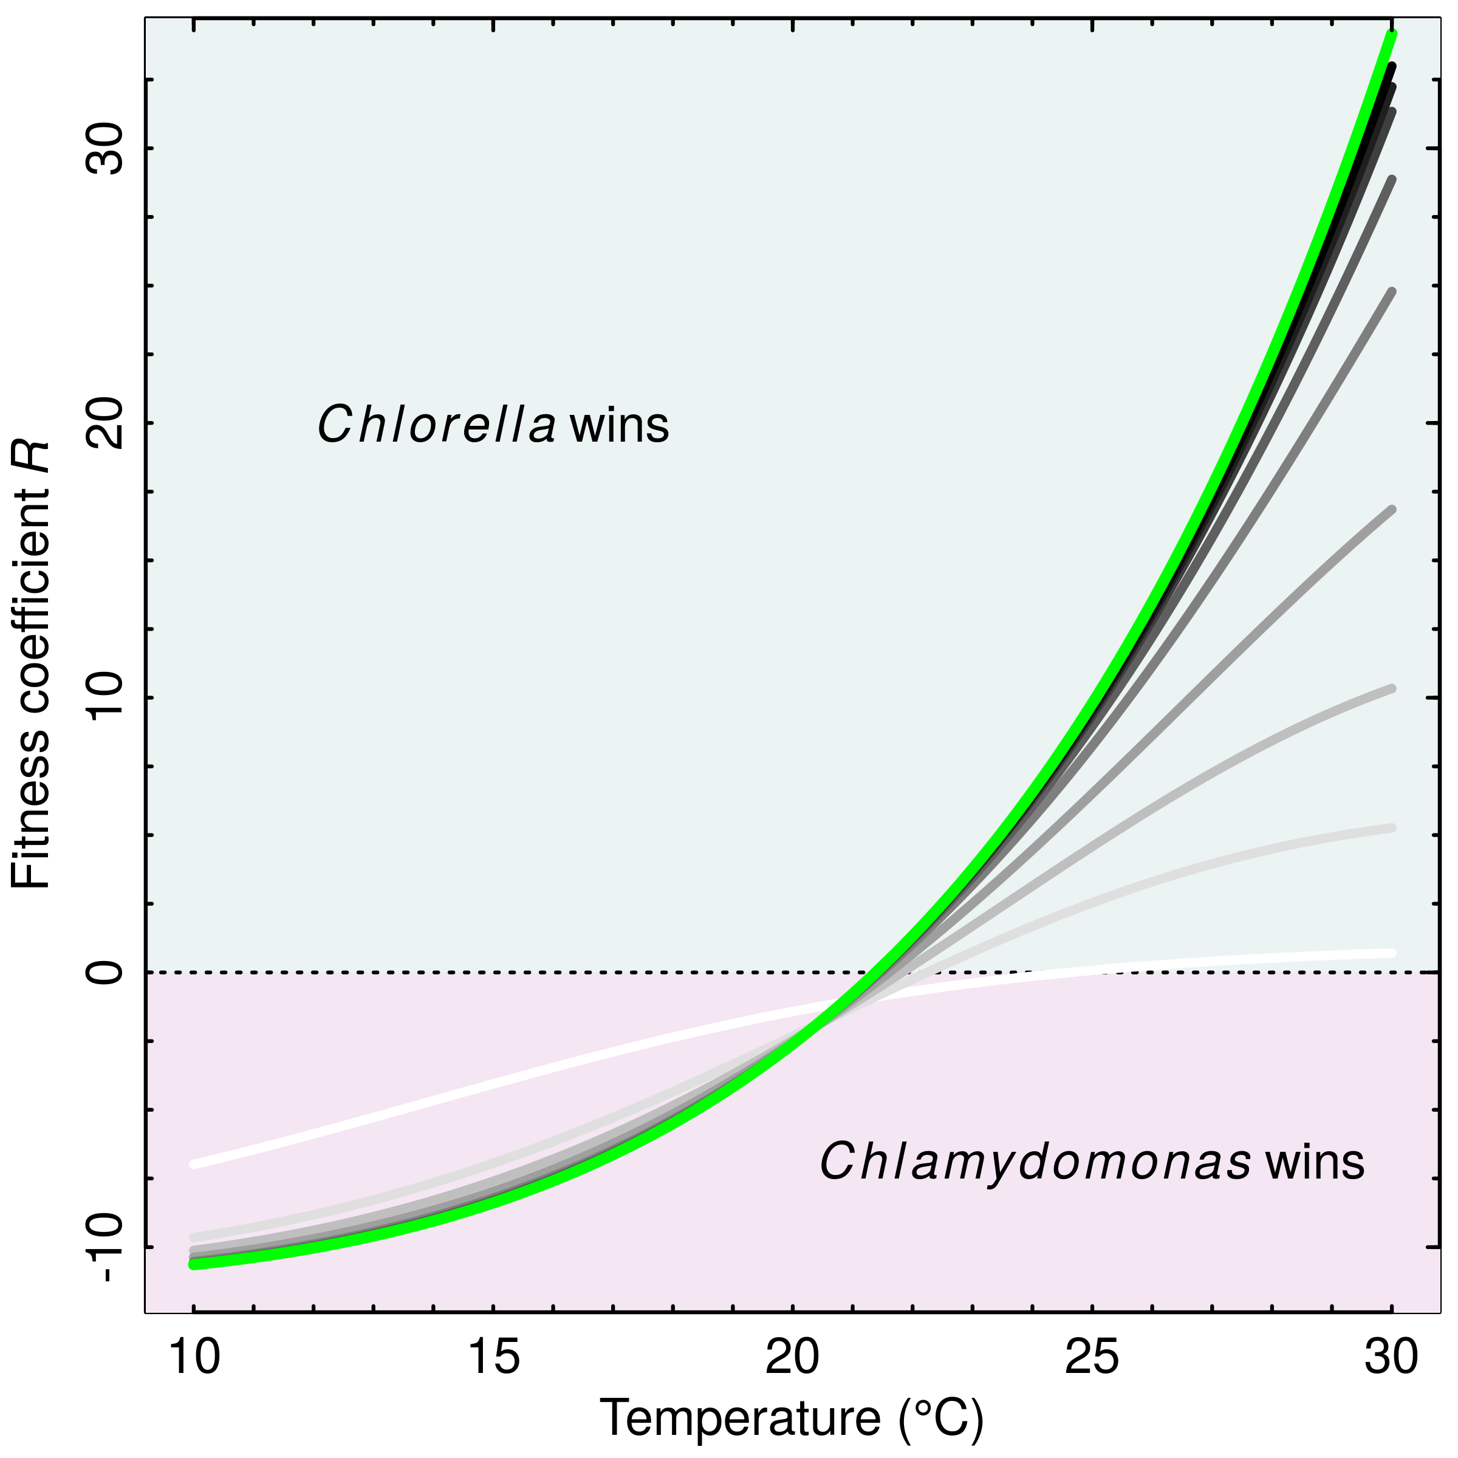

**Figure S1B:** Example of a reversal in the fitness advantage across a temperature range. The green line is for nutrient saturated conditions (), and the grayscale lines are for different nutrient concentrations, ranging from µmol·L-1 for the light gray line, to 50 µmol·L-1 for the black line. The example uses parameters for *Chlorella* and *Chlamydomonas*, where means *Chlorella* has a competitive advantage over *Chlamydomonas*.

## S2: Experimental design

### Figure S2A: Flow chart of the experimental design

6 phytoplankton species

*T°C*

*ln(µmax)*

Isolates 🡪Species discrimination function 🡪Applied to pairs of species 🡪Species identity

**Competition coefficients**

*T°C*

*ln(Ks)*

**Model**

Input: ***Temperature-dependent species physiology***

Output: **Competition coefficients**

**Temperature-and-nutrient-dependent growth rate**

For each species

*μmax*

*Ks1*

*μmax*

*μ*

*Ks1*

[P]*1*

Nutrient physiology traits

Growth rate

35°C

30°C

25°C

20°C

15°C

25°C

Pair of species

Isolate

**Competition experiment**

For each pair of species



15°C

### Table S2A:

Detailed information about the six species, ordered from the Culture Collection of Algae and Protozoa ([www.ccap.ac.uk](http://www.ccap.ac.uk))

|  |  |  |  |  |
| --- | --- | --- | --- | --- |
| **Species name** | **Class** | **Order** | **Strain** | **Origin** |
| *Ankistrodesmus nannoselene*  Skuja (1948) | Chlorophyceae | Sphaeropleales | CCAP 202/6A | Siggeforsajon, Sweden |
| *Chlamydomonas moewusii*  Gerlof (1940) | Chlorophyceae | Chlamydomonadales | CCAP 11/5A | Freshwater |
| *Chlorella sorokiniana*  Shihira & Krauss (1965) | Trebouxiophyceae | Chlorellales | CCAP 211/8K | Austin, Texas, USA |
| *Monoraphidium minutum* (Nägeli)  Komarkova-Legnerova (1969) | Chlorophyceae | Sphaeropleales | CCAP 278/3 | Texas, USA |
| *Scenedesmus obliquus* (Turpin) Kützing (1833) | Chlorophyceae | Sphaeropleales | CCAP 276/3B | Lund, Sweden |
| *Selenastrum capricornutum*  Printz (1913) | Chlorophyceae | Sphaeropleales | CCAP 278/4 | Akershus, Norway |

### Table S2B:

Phosphate concentration levels for each solution in µmol·L-1 and µg·L-1. We created 13 solutions of different phosphate concentrations ranging from 0.01 µmol·L-1 of phosphate to 50 µmol·L-1 of phosphate by mixing different amounts of COMBO medium without potassium phosphate dibasic (P- COMBO) and normal COMBO medium (P+ COMBO) in 40 mL nunclons. We used a modified version of the standard COMBO medium without animal trace solution in which we increased the fraction of carbonate by adding 10 mL of a stock solution of 55.8 g·L-1 of sodium bicarbonate to maintain a DIC of more than 6.6 mmol·L-1 in order to prevent carbon limitation, which allowed a C:N:P ratio of 132:20:1 in the P+ COMBO solution, above the Redfield ratio of 106:16:1.

|  |  |  |  |  |  |  |  |  |  |  |  |  |  |
| --- | --- | --- | --- | --- | --- | --- | --- | --- | --- | --- | --- | --- | --- |
| Phosphate concentration (µmol·L-1 ) | 50 | 40 | 30 | 20 | 10 | 8 | 6 | 4 | 2 | 1 | 0.5 | 0.1 | 0.01 |
| Phosphate concentration (µg·L-1 ) | 4750 | 3800 | 2850 | 1900 | 950 | 760 | 570 | 380 | 190 | 95 | 47.5 | 9.5 | 0.95 |
| Amount of P+ COMBO (mL) | 40 | 32 | 24 | 16 | 8 | 6.4 | 4.8 | 3.2 | 1.6 | 0.8 | 0.4 | 0.08 | 0.008 |
| Amount of P- COMBO (mL) | 0 | 8 | 16 | 24 | 32 | 33.6 | 35.2 | 36.8 | 38.4 | 39.2 | 39.6 | 40 | 40 |

## S3: Discrimination between species in the competition experiment

To investigate the joint effects of temperature and phosphate availability on competition, we competed all species in all pairwise combinations (15 pairs) at two temperatures (15 and 25°C; low temperature and a temperature close to the optimum for most species, Fig. 1) and two phosphate concentrations (saturating [30 µmol·L-1] and limiting [1 µmol·L-1] concentrations, chosen from the Monod curves, Fig. 1), with each replicated 6 times (Fig. S2A), amounting to 360 samples. Along with the pairwise competition trials, we grew all 6 species in monoculture at the two temperatures and two nutrient levels. This was done to allow for the training of the discrimination algorithm used to separate cells from different species in the competition trial. The monoculture trials were divided into two subsets, one training subset, used to train the cell discrimination algorithm, which was replicated 3 times per temperature and nutrient levels, and a testing subset used to test the accuracy of the cell discrimination algorithm, which was replicated 6 times. This testing subset was also used to calculate total yield in monoculture to compare it to yield in biculture (see Section S8). The competition experiments were carried out in 24 well plates filled with 2 mL of media, and inoculated with 100 cells·mL-1 of each species. Plates were covered with AeraSeal breathable membrane, minimising evaporation and contamination but allowing gas exchange. The competition plates were incubated in the same way as described above for the monoculture growth curves. After 14 days, a 200 µL sample was taken and preserved as described above. Cell density was determined by flow cytometry on the slow flux setting (14 µL·min), counting 20 µL per sample.

FSC files returned by the flow cytometer were read with the Bioconductor ‘FlowCore’ package in R, returning side scatter (SSC), forward scatter (FSC), green fluorescence (FL1), orange fluorescence (FL2), red fluorescence (FL3), and blue fluorescence (FL4) values that could be used to define species morphology and pigment composition and thus discriminate between species in pairwise competition samples and determine species identity for each cell. We first filtered the data to remove noise by removing every data point where either ln(FSC.H)<10.3, ln(SSC.H)<3 or ln(FL3.H)<1.5, which are below minimum values observed for life cells of all 6 species. We then separated the data set into 3 data frames, one for the training subset isolates, one for the testing subset isolates inoculated, and one for the competing species. The training isolates dataset was used to determine pairwise discrimination functions between pair of species. We first removed outliers from this dataset by manually inspecting FSC.H by FL3.H clustering plots and choosing visual thresholds for these two values for each species. We then applied 3 different procedures to discriminate between pairs of species for each temperature and phosphate level: a linear discriminant analysis with the ‘lda’ function from the ‘MASS’ package, a random forest analysis with the ‘randomForest’ function from the ‘randomForest’ package and a recursive partitioning and regression tree analysis with the ‘rpart’ function from the ‘rpart’ package. These analyses were performed using the natural logarithm of the 10 variables returned by the flow cytometer (that is FSC.H, FSC.A, SSC.H, SSC.A, FL1.H, FL1.A, FL2.H, FL2.A, FL3.H, FL3.A, FL4.H and FL4.A, .H standing for height and .A for area), on each of the 15 pairs of species for each combination of temperature and phosphate level. These different discriminant functions were then applied to the testing isolates dataset previously filtered by removing visually determined outliers to test the accuracy of the predictions for the different discriminant methods. For each pair of species, we used the training set to create in silico competition experiments where 100 % of the cells would pertain to one of the species. We applied the discrimination algorithm and calculated the percentage of times where a cell was wrongly attributed to the other species. We then chose the method that gave the maximum level of accuracy to apply to the competition dataset (Fig. S3A). The best method was the linear discriminant analysis that gave 84 % of accuracy in predicting species identity (Table S3A).

After determining species identity for each sample, we computed cell density and calculated the competitive advantage of species relative to species by taking the ln ratio of their densities (cells·mL-1) at time , adding 1 to each species density to avoid potential division per 0 issues when one species had disappeared. We also computed a binary competition advantage where species was competitively dominant for and species was dominant conversely.

### Table S3A:

Proportion of correct assignations for each discrimination method (LDA: linear discriminant analysis, Random Forest analysis, RPART: recursive partitioning and regression tree) summarised by (a) species for all nutrient and thermal conditions, (b) pair of species for all nutrient and thermal conditions, (c) phosphate and nutrient conditions for all pair of species.

a

|  |  |  |  |
| --- | --- | --- | --- |
| **Species** | **LDA** | **Random forest** | **RPART** |
| *Ankistrodesmus* | 0.91 | 0.86 | 0.72 |
| *Chlamydomonas* | 0.93 | 0.93 | 0.81 |
| *Chlorella* | 0.85 | 0.86 | 0.67 |
| *Monoraphidium* | 0.84 | 0.78 | 0.65 |
| *Scenedesmus* | 0.83 | 0.77 | 0.61 |
| *Selenastrum* | 0.70 | 0.68 | 0.48 |
| **Mean** | **0.84** | **0.81** | **0.66** |

b

|  |  |  |  |
| --- | --- | --- | --- |
| **Pair of species** | **LDA** | **Random forest** | **RPART** |
| *Ankistrodesmus-Chlamydomonas* | 1 | 1 | 0.94 |
| *Ankistrodesmus-Chlorella* | 0.91 | 0.88 | 0.73 |
| *Ankistrodesmus-Monoraphidium* | 0.87 | 0.74 | 0.71 |
| *Ankistrodesmus-Scenedesmus* | 0.95 | 0.93 | 0.71 |
| *Ankistrodesmus-Selenastrum* | 0.82 | 0.73 | 0.52 |
| *Chlamydomonas-Chlorella* | 0.96 | 0.96 | 0.79 |
| *Chlamydomonas-Monoraphidium* | 0.96 | 0.97 | 0.86 |
| *Chlamydomonas-Scenedesmus* | 0.94 | 0.92 | 0.74 |
| *Chlamydomonas-Selenastrum* | 0.78 | 0.8 | 0.74 |
| *Chlorella-Monoraphidium* | 0.83 | 0.85 | 0.7 |
| *Chlorella-Scenedesmus* | 0.86 | 0.84 | 0.65 |
| *Chlorella-Selenastrum* | 0.67 | 0.76 | 0.48 |
| *Monoraphidium-Scenedesmus* | 0.88 | 0.69 | 0.63 |
| *Monoraphidium-Selenastrum* | 0.68 | 0.67 | 0.33 |
| *Scenedesmus-Selenastrum* | 0.53 | 0.46 | 0.34 |
| **Mean** | **0.84** | **0.81** | **0.66** |

c

|  |  |  |  |  |
| --- | --- | --- | --- | --- |
| **Temperature** | **Nutrient** | **LDA** | **Random forest** | **RPART** |
| 15 | 1 | 0.79 | 0.68 | 0.64 |
| 15 | 30 | 0.85 | 0.8 | 0.76 |
| 25 | 1 | 0.7 | 0.69 | 0.68 |
| 25 | 30 | 0.64 | 0.66 | 0.62 |
| **Mean** | | **0.75** | **0.71** | **0.68** |

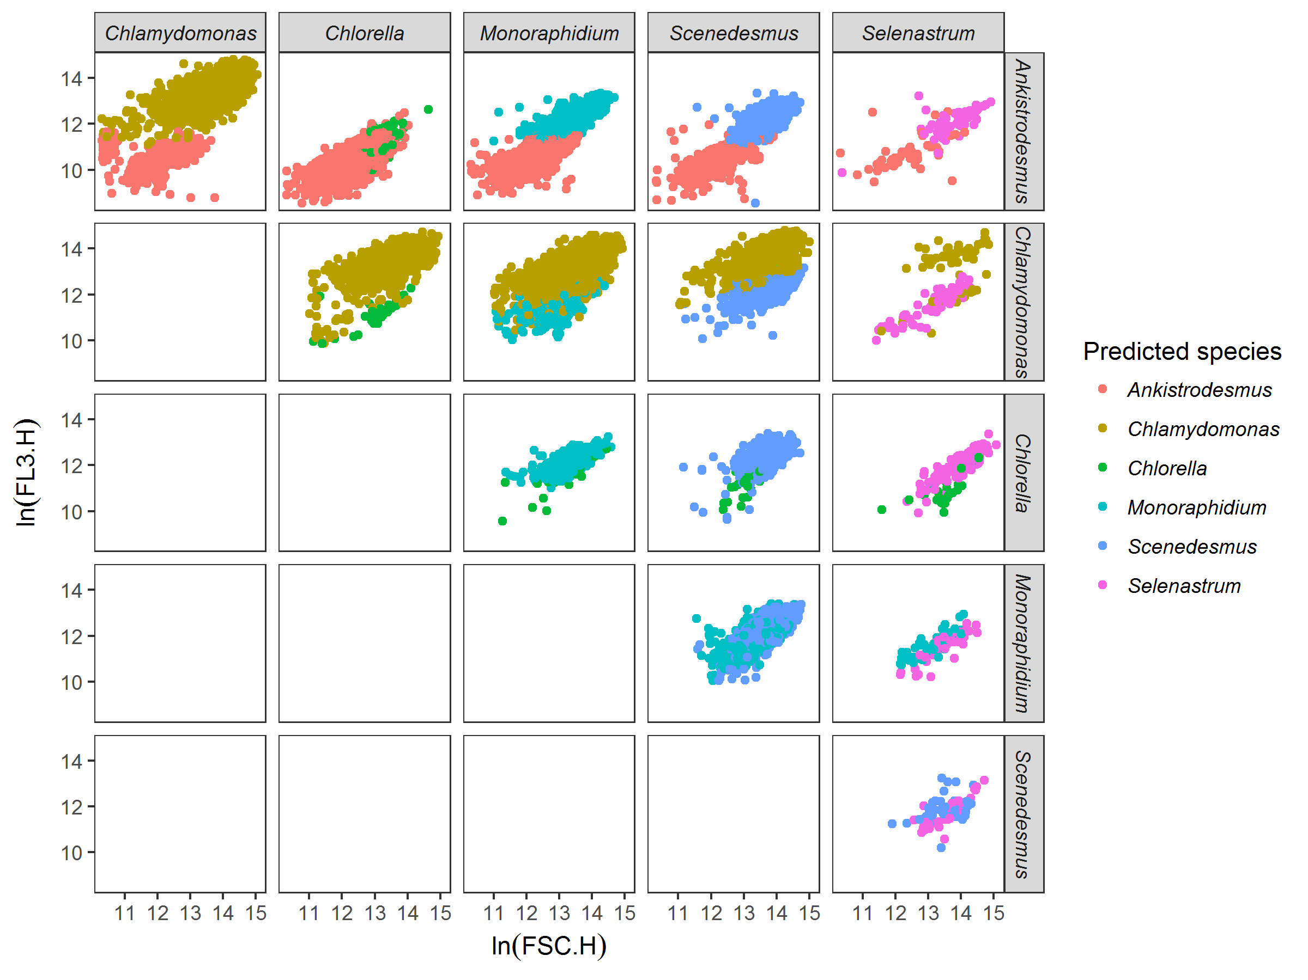

### Figure S3A:

Example of discrimination between species among pairs of species, here for species grown at 15°C in saturating nutrient conditions after 14 days of experiment. Each dot represents a cell, here mapped on FSC.H (size proxy) and FL3.H (chlorophyll a proxy) characteristics from the flow cytometer. Colours represent the species predicted by the discrimination algorithm. The discrimination algorithm is a linear discriminant analysis trained with flow cytometer data (FSC.H, FSC.A, SSC.H, SSC.A, FL1.H, FL1.A, FL2.H, FL2.A, FL3.H, FL3.A, FL4.H, and FL4.A) from the species grown in isolates at the same temperature and nutrient conditions. For example, *Chlamydomonas* has a competitive advantage over *Chlorella* in these nutrient and temperature conditions (more cells from *Chlamydomonas*).

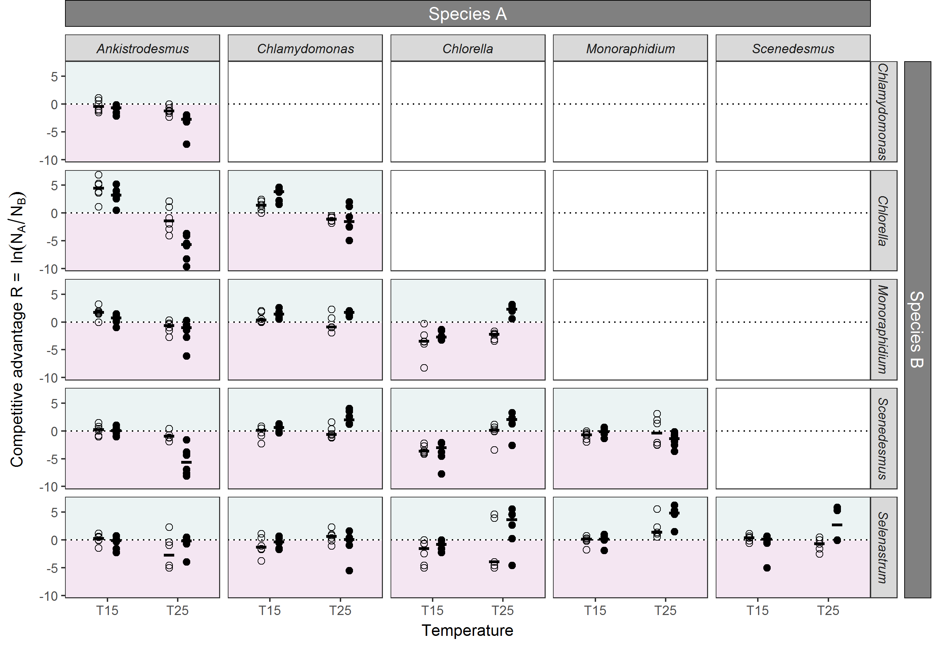

## Fig. S3B:

Competition between species. For each pair of species, the competitive advantage calculated as ln(NA/NB). Shapes represent the nutrient conditions of the trial, open circles: non-saturated nutrient solution (1 μmol·L-1 of phosphate), closed circles, saturated nutrient solution (30 μmol·L-1 of phosphate). Points represent the values of the 6 replicates per condition, and the black segment represents the median of the 6 replicates. The dotted line represents the situation where there is no competitive advantage between the species (NA = NB). Area above the line shows an advantage for species A (turquoise colour), while area below the line shows and advantage for species B (pink colour). We can see for instance that for the *Ankistrodesmus-Chlorella* pair of species, *Ankistrodesmus* dominates at low temperatures for all nutrient conditions while *Chlorella* dominates at high temperatures, particularly at high nutrient conditions.

## S4: Temperature dependence of the Monod model parameters

### Table S4A:

Normalization constants ( and resp. for and ) and activation energies ( and resp. for and ) derived from a Boltzmann-Arrhenius model on linear scales using nonlinear least squares to the values of and ln( for all replicates, for temperatures between 15 and 25°C, and using a reference temperature °C (estimates ± SE).

|  |  |  |  |  |
| --- | --- | --- | --- | --- |
| **Species** | **Ks** | |  | |
|  |  |  |  |  |
| *Ankistrodesmus* | -6.49 ± 0.51 | 3.26 ± 0.59 | -0.39 ± 0.04 | 0.27 ± 0.05 |
| *Chlamydomonas* | -2.47 ± 0.63 | 0.96 ± 0.72 | 0.15 ± 0.07 | 0.16 ± 0.08 |
| *Chlorella* | -2.71 ± 0.19 | 1.49 ± 0.22 | -0.58 ± 0.07 | 0.99 ± 0.08 |
| *Monoraphidium* | -3.44 ± 0.73 | 1.47 ± 0.83 | -0.54 ± 0.09 | 0.59 ± 0.10 |
| *Scenedesmus* | -1.30 ± 0.46 | 0.00 ± 0.52 | 0.22 ± 0.07 | 0.00 ± 0.08 |
| *Selenastrum* | -1.67 ± 0.46 | 2.91 ± 0.52 | -0.48 ± 0.17 | 0.97 ± 0.20 |

### Table S4B:

Results from the GAMs where ln( is a function of temperature, for each species. See Fig 1 for the representation of the GAMs.

|  |  |  |  |  |
| --- | --- | --- | --- | --- |
| **Species** | **edf** | **F** | **p-value** | **R2** |
| *Ankistrodesmus* | 2 | 8.33 | 0.005** | 0.51 |
| *Chlamydomonas* | 2 | 3.96 | 0.048* | 0.30 |
| *Chlorella* | 2 | 113.6 | >0.001*** | 0.94 |
| *Monoraphidium* | 2 | 70.4 | >0.001*** | 0.91 |
| *Scenedesmus* | 2 | 0.34 | 0.716 | -0.10 |
| *Selenastrum* | 2 | 10.6 | 0.002** | 0.58 |

### Table S4C:

Results from the GAMs where ) is a function of temperature, for each species. See Fig 1 for the representation of the GAMs.

|  |  |  |  |  |
| --- | --- | --- | --- | --- |
| **Species** | **edf** | **F** | **p-value** | **R2** |
| *Ankistrodesmus* | 2 | 31.6 | >0.001*** | 0.81 |
| *Chlamydomonas* | 2 | 4.39 | 0.037* | 0.33 |
| *Chlorella* | 2 | 27.5 | >0.001*** | 0.79 |
| *Monoraphidium* | 2 | 6.21 | 0.014* | 0.43 |
| *Scenedesmus* | 2 | 1.49 | 0.265 | 0.06 |
| *Selenastrum* | 2 | 21.6 | 0.001** | 0.75 |

## S5: Significance of competitive advantage predicted by the model

To quantify the significance of the theory’s ability to predict competitive advantage, we ran the analysis 10,000 times, sampling the values of , , , and independently, with replacement, from the pool of available values. When assessing the theory’s performance for a particular subset, for example, for competitions at °C, parameters were sampled independently from all values estimated at °C only. The analysis produced 10,000 proportions of competitive advantage correctly predicted. The proportion of runs that correctly predicted a greater number of competitive advantages than the real parameter values are then given as the P values in Table 1. Therefore, P=0.05 means that 500 out of 10,000 random parameter combinations correctly predicted a greater proportion of competitive advantage. Similarly, the analysis produced 10,000 predictions of reversals in fitness advantage. The proportions of runs that correctly predicted a greater number of fitness advantage reversals than the real parameter values are given as the P values in Table 1.

## S6: Robustness of the results to different statistical methods

We used three different methods of discrimination to determine the number of cells from each species, a linear discriminant analysis, a random forest analysis and a recursive partitioning and regression tree (rpart, see Supplementary Material S3). Because the linear discriminant analysis was found to have the best predictive power overall (Table S3A), we used this method throughout the manuscript. However, we tested whether our results were robust to the method of species discrimination by comparing results from the competition model to predictions using the random forest analysis and the rpart discrimination method (Table S6A and S6B). The results were similar, with a lower predictive power of each variable and of the model due to the lower discrimination power of the two methods, but no significant discrepancies between species and temperature and nutrient conditions.

### Table S6A:

Same as Table 1 in the main text, using the random forest discrimination method for the competition data.

|  |  |  | ***R*** |  | ***N*** | ***reversal*** |  | ***R(S) reversal*** |  | ***N reversals*** |
| --- | --- | --- | --- | --- | --- | --- | --- | --- | --- | --- |
| *Full dataset* | | | | | | | | |  |  |
|  | 0.63 | (0.025) | 0.66 | (0.006) | 345 | 0.58 | (0.001) | 0.58 | (0.002) | 483 |
| *By temperature* | | | | | | | | |  |  |
| °C | 0.71 | (0.022) | 0.70 | (0.028) | 175 | NA | ( NA) | NA | ( NA) |  |
| °C | 0.55 | (0.316) | 0.62 | (0.093) | 170 | NA | ( NA) | NA | ( NA) |  |
| *By nutrient* | | | | | | | | |  |  |
| [P] = 1 µmol·L-1 | 0.57 | (0.178) | 0.60 | (0.097) | 173 | 0.47 | (0.008) | 0.35 | (0.085) | 233 |
| [P] = 30 µmol·L-1 | 0.69 | (0.017) | 0.72 | (0.008) | 172 | 0.69 | (0.000) | 0.79 | (0.000) | 250 |
| *By species* | | | | | | | | |  |  |
| *Ankistrodesmus* | 0.75 | (0.004) | 0.74 | (0.004) | 118 | 0.66 | (0.014) | 0.58 | (0.038) | 179 |
| *Chlamydomonas* | 0.66 | (0.010) | 0.67 | (0.015) | 119 | 0.50 | (0.022) | 0.46 | (0.054) | 151 |
| *Chlorella* | 0.76 | (0.034) | 0.78 | (0.017) | 116 | 0.79 | (0.008) | 0.91 | (0.002) | 219 |
| *Monoraphidium* | 0.59 | (0.120) | 0.63 | (0.053) | 115 | 0.67 | (0.001) | 0.67 | (0.002) | 133 |
| *Scenedesmus* | 0.57 | (0.330) | 0.59 | (0.248) | 117 | 0.44 | (0.023) | 0.38 | (0.064) | 149 |
| *Selenastrum* | 0.44 | (0.659) | 0.53 | (0.345) | 105 | 0.29 | (0.151) | 0.29 | (0.186) | 135 |

### Table S6B:

Same as Table 1 in the main text, using the rpart discrimination method for the competition data.

|  |  |  | ***R*** |  | ***N*** | ***reversal*** |  | ***R(S) reversal*** |  | ***N reversals*** |
| --- | --- | --- | --- | --- | --- | --- | --- | --- | --- | --- |
| *Full dataset* | | | | | | | | |  |  |
|  | 0.63 | (0.024) | 0.66 | (0.007) | 345 | 0.56 | (0.002) | 0.55 | (0.004) | 494 |
| *By temperature* | | | | | | | | |  |  |
| °C | 0.70 | (0.029) | 0.70 | (0.023) | 176 | NA | ( NA) | NA | ( NA) |  |
| °C | 0.55 | (0.314) | 0.61 | (0.120) | 169 | NA | ( NA) | NA | ( NA) |  |
| *By nutrient* | | | | | | | | |  |  |
| [P] = 1 µmol·L-1 | 0.56 | (0.233) | 0.59 | (0.141) | 173 | 0.49 | (0.005) | 0.37 | (0.072) | 235 |
| [P] = 30 µmol·L-1 | 0.69 | (0.020) | 0.72 | (0.011) | 172 | 0.62 | (0.003) | 0.71 | (0.001) | 259 |
| *By species* | | | | | | | | |  |  |
| *Ankistrodesmus* | 0.75 | (0.002) | 0.73 | (0.005) | 116 | 0.64 | (0.015) | 0.56 | (0.046) | 195 |
| *Chlamydomonas* | 0.61 | (0.102) | 0.63 | (0.073) | 118 | 0.45 | (0.041) | 0.40 | (0.091) | 143 |
| *Chlorella* | 0.77 | (0.020) | 0.78 | (0.018) | 115 | 0.82 | (0.006) | 0.94 | (0.003) | 211 |
| *Monoraphidium* | 0.59 | (0.092) | 0.65 | (0.031) | 117 | 0.60 | (0.000) | 0.60 | (0.002) | 158 |
| *Scenedesmus* | 0.56 | (0.339) | 0.57 | (0.275) | 117 | 0.40 | (0.048) | 0.34 | (0.122) | 149 |
| *Selenastrum* | 0.47 | (0.589) | 0.56 | (0.243) | 107 | 0.25 | (0.196) | 0.25 | (0.237) | 132 |

## S7: Quantitative relationship between theoretical and experimental outcomes

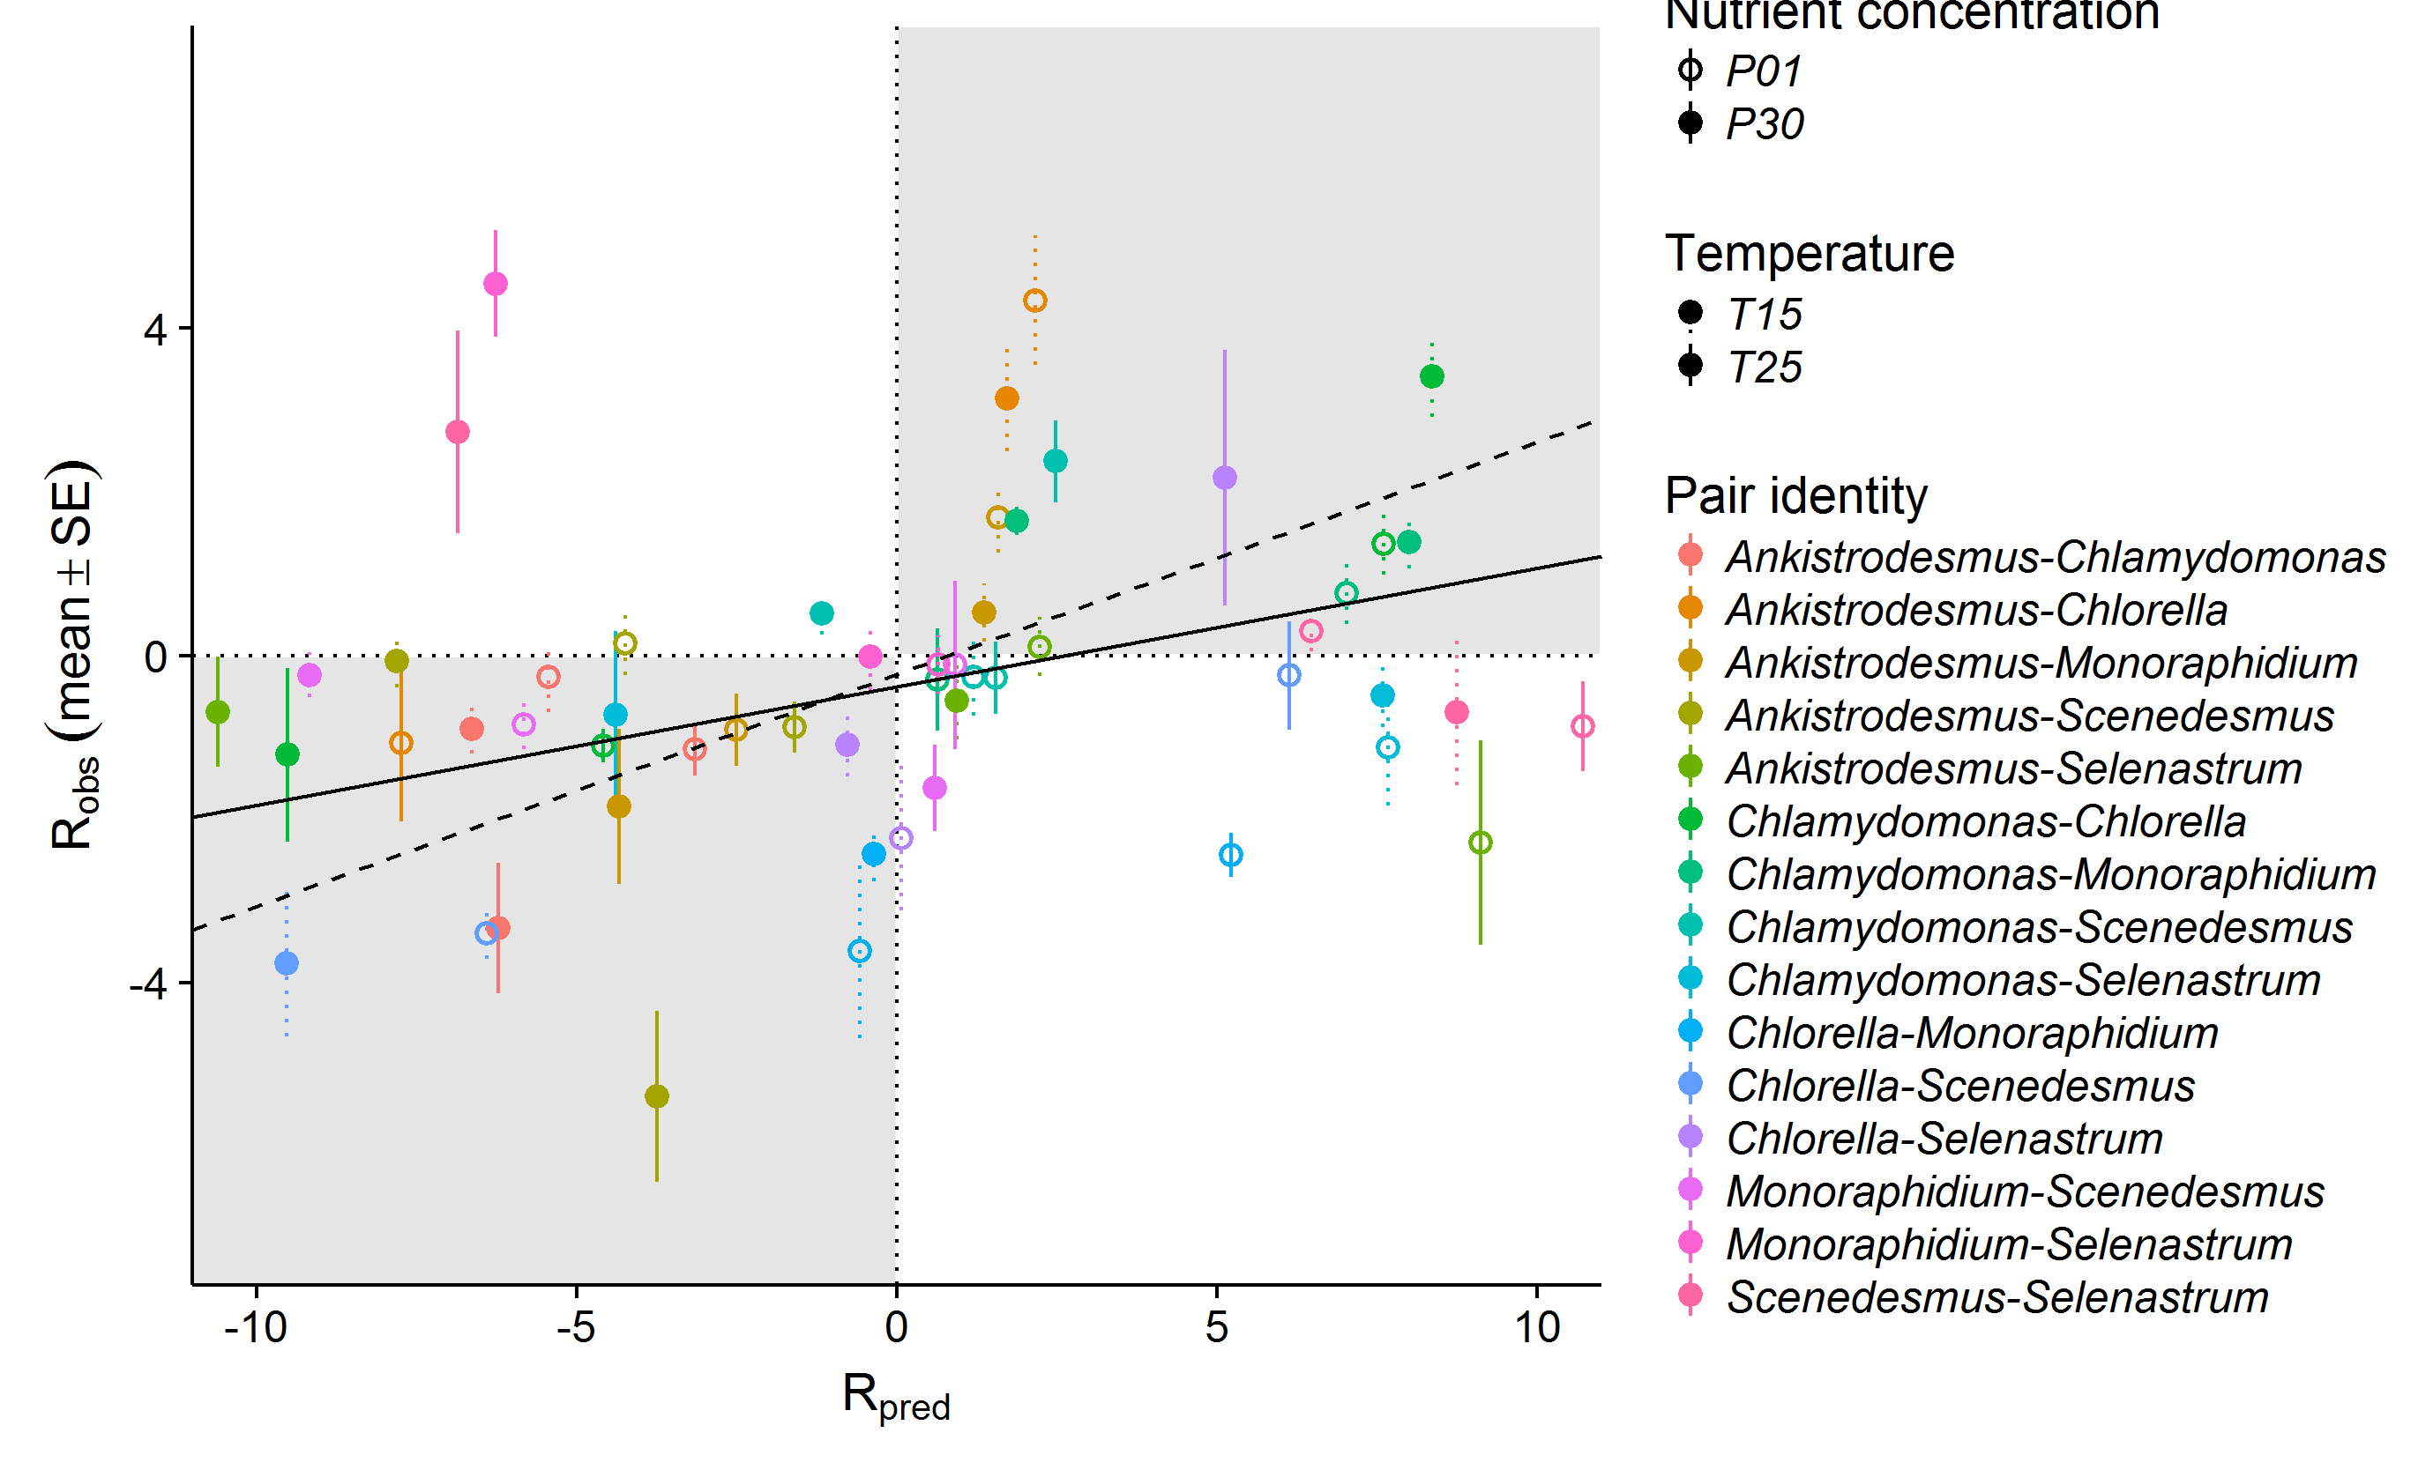

**Figure S7A:** Link between observed competitive advantage R (mean ± SE across 6 replicates) and predicted competitive advantage from the theoretical model. Different species pairs are in different colours, filled circles are for high nutrients while empty circles stand for low nutrients, and the type of the standard error line stands for the temperature (dotted for low temperature, solid for high temperature). Most of the binary experimental outcomes (sign of observed R) fall in the same region (grey rectangles) as the binary theoretical outcomes (sign of predicted R).The full line represents the results of a linear mixed model of observed R as a function of predicted R as a fixed effect plus pair ID, temperature and nutrients as random intercepts on the whole dataset, while the dashed line represents the results from the same model but excluding pairs involving *Selenastrum* (see Table S7A and Table S7B for details about the model).

**Table S7A:** Results from the linear mixed model investigating observed R as a function of predicted R as a fixed effect plus plus pair ID, temperature and nutrients as random intercepts with lmer function from lme4 package (Robs ~ Rpred + (1|temperature) + (1|nutrient) + (1|species pair)).

|  |  |  |  |  |  |
| --- | --- | --- | --- | --- | --- |
| **Factor** | **Estimate** | **SE** | **t-value** | **χ2 statistics** | **R2** |
| *Fixed effect* |  |  |  |  | ***marginal R2*** |
| Rpred | 0.14 | 0.02 | 6.72 | χ2 = 45, p > 0.001 | 0.13 |
| *Random effect* | **Variance** |  |  |  | ***conditional R2*** |
| Temperature | 0.02 |  |  |  | 0.27 |
| Nutrient | 0.25 |  |  |  |  |
| Pair identity | 0.75 |  |  |  |  |
| Residual | 5.36 |  |  |  |  |

**Table S7B:** Results from the linear mixed model investigating observed R as a function of predicted R as a fixed effect plus plus pair ID, temperature and nutrients as random intercepts with lmer function from lme4 package (Robs ~ Rpred + (1|temperature) + (1|nutrient) + (1|species pair)) on the competition dataset excluding pairs involving *Selenastrum*.

|  |  |  |  |  |  |
| --- | --- | --- | --- | --- | --- |
| **Factor** | **Estimate** | **SE** | **t-value** | **χ2 statistics** | **R2** |
| *Fixed effect* |  |  |  |  | ***marginal R2*** |
| Rpred | 0.28 | 0.02 | 12,18 | χ2 = 148.5, p > 0.001 | 0.36 |
| *Random effect* | **Variance** |  |  |  | ***conditional R2*** |
| Temperature | 0.60 |  |  |  | 0.57 |
| Nutrient | 0.00 |  |  |  |  |
| Pair identity | 1.21 |  |  |  |  |
| Residual | 3.54 |  |  |  |  |

**Table S7C:** Link between observed and predicted R by species. Results from a mixed effect model of Robs ~ Rpred + (1|temperature)+(1|nutrient)+(1|species pair) for each subset of competitions.

|  |  |  |  |  |  |
| --- | --- | --- | --- | --- | --- |
| **Species** | **Fixed Rpred effect** | | **t-value** | **Marginal R2** | **Conditional R2** |
|  | **estimate** | **SD** |  |  |  |
| *Ankistrodesmus* | 0.11 | 0.04 | 2.54 | 0.04 | 0.53 |
| *Chlamydomonas* | 0.17 | 0.03 | 6.04 | 0.26 | 0.47 |
| *Chlorella* | 0.29 | 0.03 | 9.43 | 0.37 | 0.61 |
| *Monoraphidium* | 0.11 | 0.04 | 2.88 | 0.06 | 0.39 |
| *Scenedesmus* | 0.06 | 0.04 | 1.81 | 0.03 | 0.13 |
| *Selenastrum* | -0.04 | 0.04 | -1.12 | 0.01 | 0.24 |

## S8: Impact of competitive interactions on community functioning

We computed the total cell density of the two species grown in competition and the total cell density of each species grown isolation. We calculated a deviation from expected yield according to (Loreau & Hector 2001), as

Where is the observed yield of the two-species mixture (in cells·mL-1), is the expected yield of the two-species mixture, and and are the observed and expected relative yields of species *i* in the mixture. The expected relative yield of species *i* in the mixture are equal to half of the yield observed in monoculture (as they have theoretically access to half of the nutrients in a two-species mixture). We studied whether the deviation from expected yield varied with species identity (Table S8A). Positive deviations indicate complementarity effects (e.g. niche partitioning or facilitation) while negative deviations indicate competitive interactions diminishing total biomass. Although all interactions were generally negative, interactions involving *Selenastrum* were strongly negative, while interactions involving *Scenedesmus* were less negative (Table S8A).

**Table S8A**: Deviation from the expected yield per species, values from two tailed t test of

|  |  |  |  |  |  |
| --- | --- | --- | --- | --- | --- |
| **Species** | **mean** | **Confidence interval** | **t-value** | **df** | **pvalue** |
| *Ankistrodesmus* | -0.36 | [-0.48,-0.25] | -6.30 | 119 | >0.001*** |
| *Chlamydomonas* | -0.16 | [-0.25,-0.06] | -3.31 | 119 | 0.001** |
| *Chlorella* | -0.15 | [-0.27,-0.04] | -2.63 | 119 | 0.009** |
| *Monoraphidium* | -0.14 | [-0.22,-0.06] | -3.43 | 118 | >0.001*** |
| *Scenedesmus* | -0.12 | [-0.23,-0.01] | -2.22 | 119 | 0.028* |
| *Selenastrum* | -0.74 | [-0.85,-0.63] | -13.40 | 119 | >0.001*** |